Department Of
Biochemistry &
Molecular Biology

BMB Weekly
Vol. 54, No. 8
February 22 – 26

COLLEGE OF NATURAL SCIENCE | bmb.msu.edu
Please send submissions to Jeff Mason, masonje6@msu.edu
Seminar Calendar
Noteworthy News

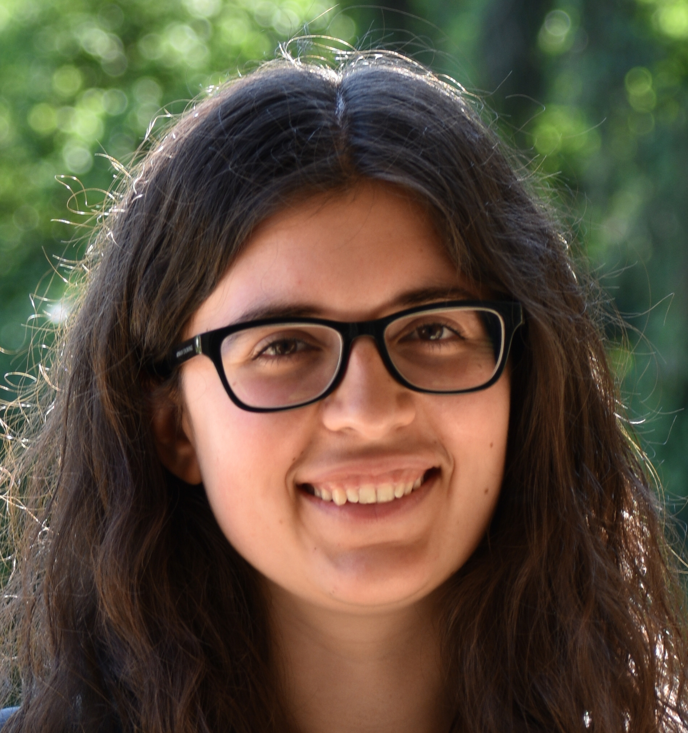

Please join me in congratulating Ana-Maria Raicu, a graduate student in David Arnosti's lab, who was recently selected to serve as the Trainee Representative on the FlyBoard. The FlyBoard is made up of scientists across North America, who use Drosophila as their primary model organism.

As representative, she will contribute a student’s perspective on what the fly community needs to improve access to resources and facilitate communication between trainees and researchers.

Spartans Will.

Monday, February 22
Molecular Plant Science Seminars
Eric Schmelz, University of California San Diego
“Mechanisms for plant recognition of animals: a case for reasonable receptor-ligand candidates in legumes”
4:00 PM
Zoom link (Passcode: 941910)

Tuesday, February 23
The Exchange – (Science discussion for BMB graduate students)
“Journal Club on Dr. Sarah Keane, U. Michigan”
8:00 AM
Email David (arnosti@msu.edu) for the Zoom link and password

PRL Tuesday Noon Seminars
Danielle Young, MSU (Shachar-Hill Lab)
Noon
Zoom link (passcode 941910)

Microbiology & Molecular Genetics Seminars
Kinjal Majumder, University of Wisconsin-Madison.
“How do small DNA viruses navigate the nuclear environment to establish infection?”
3:10 PM
Zoom link
Email Ashley (shadeash@msu.edu) for the password

Thursday, February 25
BMB Seminar Series
Sarah Keane, U Michigan
“Precursor microRNA structure and dynamics”
11:00 AM
Email Ashley (clarkas@msu.edu) for the Zoom link

EEB Seminar Series
Angela Strecker, Institute for Watershed Studies - Western Washington University
“What are the roles of connectivity and the environment in structuring freshwater communities?”
3:30 PM
Email Barbara (eeb@msu.edu) for the Zoom link

Announcements

Don’t forget to follow MSU_BMB on Twitter.

GRIT's upcoming movie event on March 4th at 7pm will have people view the 2016 movie "Hidden Figures" in advance, then meet and greet and discussion about the film. Graduate students and faculty are both welcome. Register here in advance to receive the Zoom link and a snack bag.

"Broader Impacts of Research: Strategies, Resources & Partners" Virtual Conference - March 17-18. Open to all, this conference will offer participants an overview of the Broader Impacts (BI) of research criterion for NSF grants, and provide resources, supports and partners available to help them design innovative activities. Registration is open here.

Applications are due March 1 for the IMPACTS program, which aims at training doctoral students in their first or second year, to employ computational and data science approaches to analyze and interpret heterogeneous, multi-scale measurement data to predict plant responses in variable environments at local to global scales. See this application document for details.

MSU SciComm will be hosting a virtual SciComm Conference, “Conveyance,” on March 20th and 21st. Workshop and speakers will encompass MSU SciComm’s main methods of communicating science to the public: art, policy, outreach/public engagement, reporting, and writing. Featured speakers and registration can be found here.

Jonathan Monroe (monroejd@jmu.edu) in the Department of Biology at James Madison University is hiring a postdoc that intends to seek out a career at a primarily undergraduate institution (PUI). The postdoc will gain experience mentoring undergrads in the lab and teaching both lecture and lab courses.

Recent Publications

Roach TNF, Dilworth J, Martin Hernandez C, Jones DA, Quinn RA, Drury C. “Metabolomic signatures of coral bleaching history.” Nat Ecol Evol. Volume 5. February 2021.

Heo L, Arbour CF, Janson G, Feig M. “Improved Sampling Strategies for Protein Model Refinement Based on Molecular Dynamics Simulation.” J Chem Theory Comput. Volume 17. February 2021. Online ahead of print.

