Department Of
Biochemistry &
Molecular Biology

BMB Weekly
Vol. 54, No. 9
March 1 – 5

COLLEGE OF NATURAL SCIENCE | bmb.msu.edu
Please send submissions to Jeff Mason, masonje6@msu.edu
Seminar Calendar
Noteworthy News

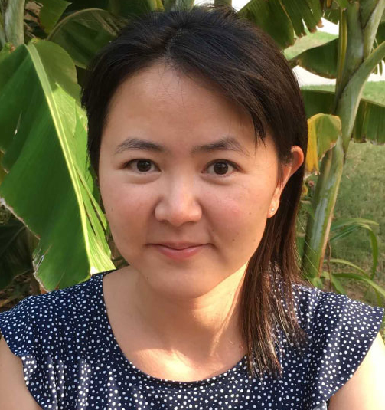

Congratulations to Polly Hsu, who received a $1.2 million National Science Foundation grant to probe plant genetics at a new level to better understand how crops cope with drought.

This work could help farmers and scientists better protect plants as water scarcity is projected to affect more and more people over the next century.

Click here to read more….

Spartans Will.

Monday, March 1
Molecular Plant Science Seminars
Om Parkash Dhankher, University of Massachusetts Amherst
“Metabolic engineering of Camelina sativa for enhanced oil production and increasing tolerance to abiotic stresses”
4:00 PM Zoom link (Passcode: 941910)

Tuesday, March 2
The Exchange – (Science discussion for BMB graduate students)
“Journal Club on Dr. Geraldine Seydoux, Johns Hopkins”
8:00 AM
Email David (arnosti@msu.edu) for the Zoom link and password

PRL Tuesday Noon Seminars
Leah Johnson, MSU (Howe Lab)
Noon Zoom link (passcode 941910)

Wednesday, March 3
Metabolism, Membranes and Metalloenzymology Interest Group
Nick Schlect (Hamberger lab)
“Cytochromes P450, gate keepers in plant specialized metabolism”
4:00 PM Email Teri (compeaut@msu.edu) for the Zoom link

Thursday, March 4
BMB Seminar Series
Geraldine Seydoux, Johns Hopkins
“Regulation of RNA granule assembly by intrinsically-disordered proteins”
11:00 AM Email Ashley (clarkas@msu.edu) for the Zoom link

EEB Seminar Series
Joanna Schmidt, University of California - Davis
“How natural variation in the seasonal germination niche shapes plant life histories and climate adaption”
3:30 PM Email Barbara (eeb@msu.edu) for the Zoom link

Friday, March 5
Plant Biology Seminar Series
Anna Monfils, Central Michigan University
“Biodiversity Science in the 21st Century: Extending Biological Collections for Enhanced Research, Conservation, and Education”
3:30 PM Email Chasidy (perezch2@msu.edu) for the Zoom link

Announcements

"Postdoc Parenting: Challenges and Strategies for New Postdoc Parents" Webinar - Wednesday, March 3 - 1pm EST will provide an overview of the challenges faced by postdoc parents as well as the strategies used to succeed as a new parent postdoc. Register here.

The Women’s Advisory Committee for Support Staff (WACSS) invites you to join their Annual Spring Forum on Wednesday, March 24 via Zoom. The Forum, entitled “From Where We Stand: Leading Through Intersectionality,” will lead participants through an exploration of ways each of us can create a more inclusive and equitable workplace and community.

The Bailey Scholars Program is offering the opportunity for graduate students (Master’s and PhD) in any discipline to apply to be a Graduate Fellow with the program to further their development in the scholarship of teaching and learning. Questions should be addressed to Jennifer (Jeno) Rivera (jeno@msu.edu) or check out their website for more information about the program.

The Department of Chemistry & Biochemistry at the University of Arizona has initiated a search for a tenure-track, open-rank Professor in the area of Structural Biology and Biochemistry. The complete position description and application instructions/links may be found here.

Service of belts and filters on HVAC equipment in the Biochemistry building will be performed from 5 p.m. to 11:55 p.m., on Wednesday, March 3. During this shutdown, fume hood exhaust and building ventilation will be affected. Building occupants may notice a change in building temperature. Please cover/contain all hazardous materials within the fume hoods and close all fume hood sashes during this shutdown.

Updates on equipment - BMB Purchased a new X-ray film developer to replace the old one – should be installed in the next 3-4 weeks. Purchased a new agarose gel documentation system (for EtdBr) – will be placed on the 3rd floor. The Azure imaging system that was housed in Rm 319 (vacant lab) is being moved to BCH 418C.

Recent Publications

Xu Y, Fu X, Sharkey TD, Shachar-Hill Y, Walker BJ. "The metabolic origins of non-photorespiratory CO2 release during photosynthesis: A metabolic flux analysis.” Plant Physiol. Volume 185. Feb 2021. Online ahead of print.

Musa MM, Vieille C, Phillips RS. “Secondary Alcohol Dehydrogenases from Thermoanaerobacter pseudoethanolicus and Thermoanaerobacter brockii as Robust Catalysts.” ChemBioChem. Volume 22. Feb 2021. Online ahead of print.

