Exam #1 BMB 514 – Medical Biochemistry 9/17/10

STEP 1 - NAME (Print clearly) _________________ ____________________________
(first) (last)

Circle your college and campus: 301 --- CHM-EL
302 --- CHM-GR
303 --- COM-EL
304 --- COM-DMC
305 --- COM-MUC

STEP 2 – Fill in your answer sheet with a #2 scoring pencil, as follows:

- Print your first and last name on the line provided
- Code in your Student Number (PID)
- Your section is already coded on your scantron.
- Code in the correct FORM ..... This is Form A
- Sign your name in the signature box. By signing the answer sheet for this exam, the student certifies that he/she has adhered to the policies of academic honesty in the performance of this exam.

STEP 3 - Read these instructions:
- Page 2 of this exam contains information that may be useful to you: (a) abbreviations for the amino acids; (b) pKa values of functional groups; and (c) table of logarithms.
- A simple calculator is supplied for your use during this exam. No other electronic or computational devices are to be used. Turn off cell phones; keep them out of sight.
- The proctors have the authority/responsibility to assign any student a different seat at any time, without implication and without explanation, before or during the examination, as they deem necessary. Accomplish any relocation quietly and without discussion.
- Make sure your exam has 32 questions.
- We will not answer questions of clarification. However, if you think there is an error on your exam, summon an exam proctor.
- Read each question very carefully. Choose the single, best answer and mark this answer on your answer sheet. No points will be added for correct answers which appear on the exam page but not on the answer sheet.
- When you finish, carefully follow the instructions at the end of the exam. When you leave the exam room, please turn in your answer sheet AND your exam to the proctors standing by the doors INSIDE the auditorium. Once you exit the auditorium, please leave the building. Hallway conversations disturb those still taking the exam.
- There will be answer keys to this exam posted on the course website by 5:00 p.m. the day of the exam. You may wish to copy your responses from your answer sheet onto the answer grid on the LAST page of this exam so that you can check your results. You can tear off the last page and take it with you.
- You have 70 minutes to complete this exam. No additional time will be allowed for transfer of answers from the exam to the answer sheet. We will close the exam promptly at 9:10 a.m. Once we withdraw the boxes for the answer sheets from the doors, no additional answer sheets will be accepted.

STEP 4 – Wait until instructed to proceed with the exam!

INFORMATION THAT MAY BE USEFUL FOR THE EXAM

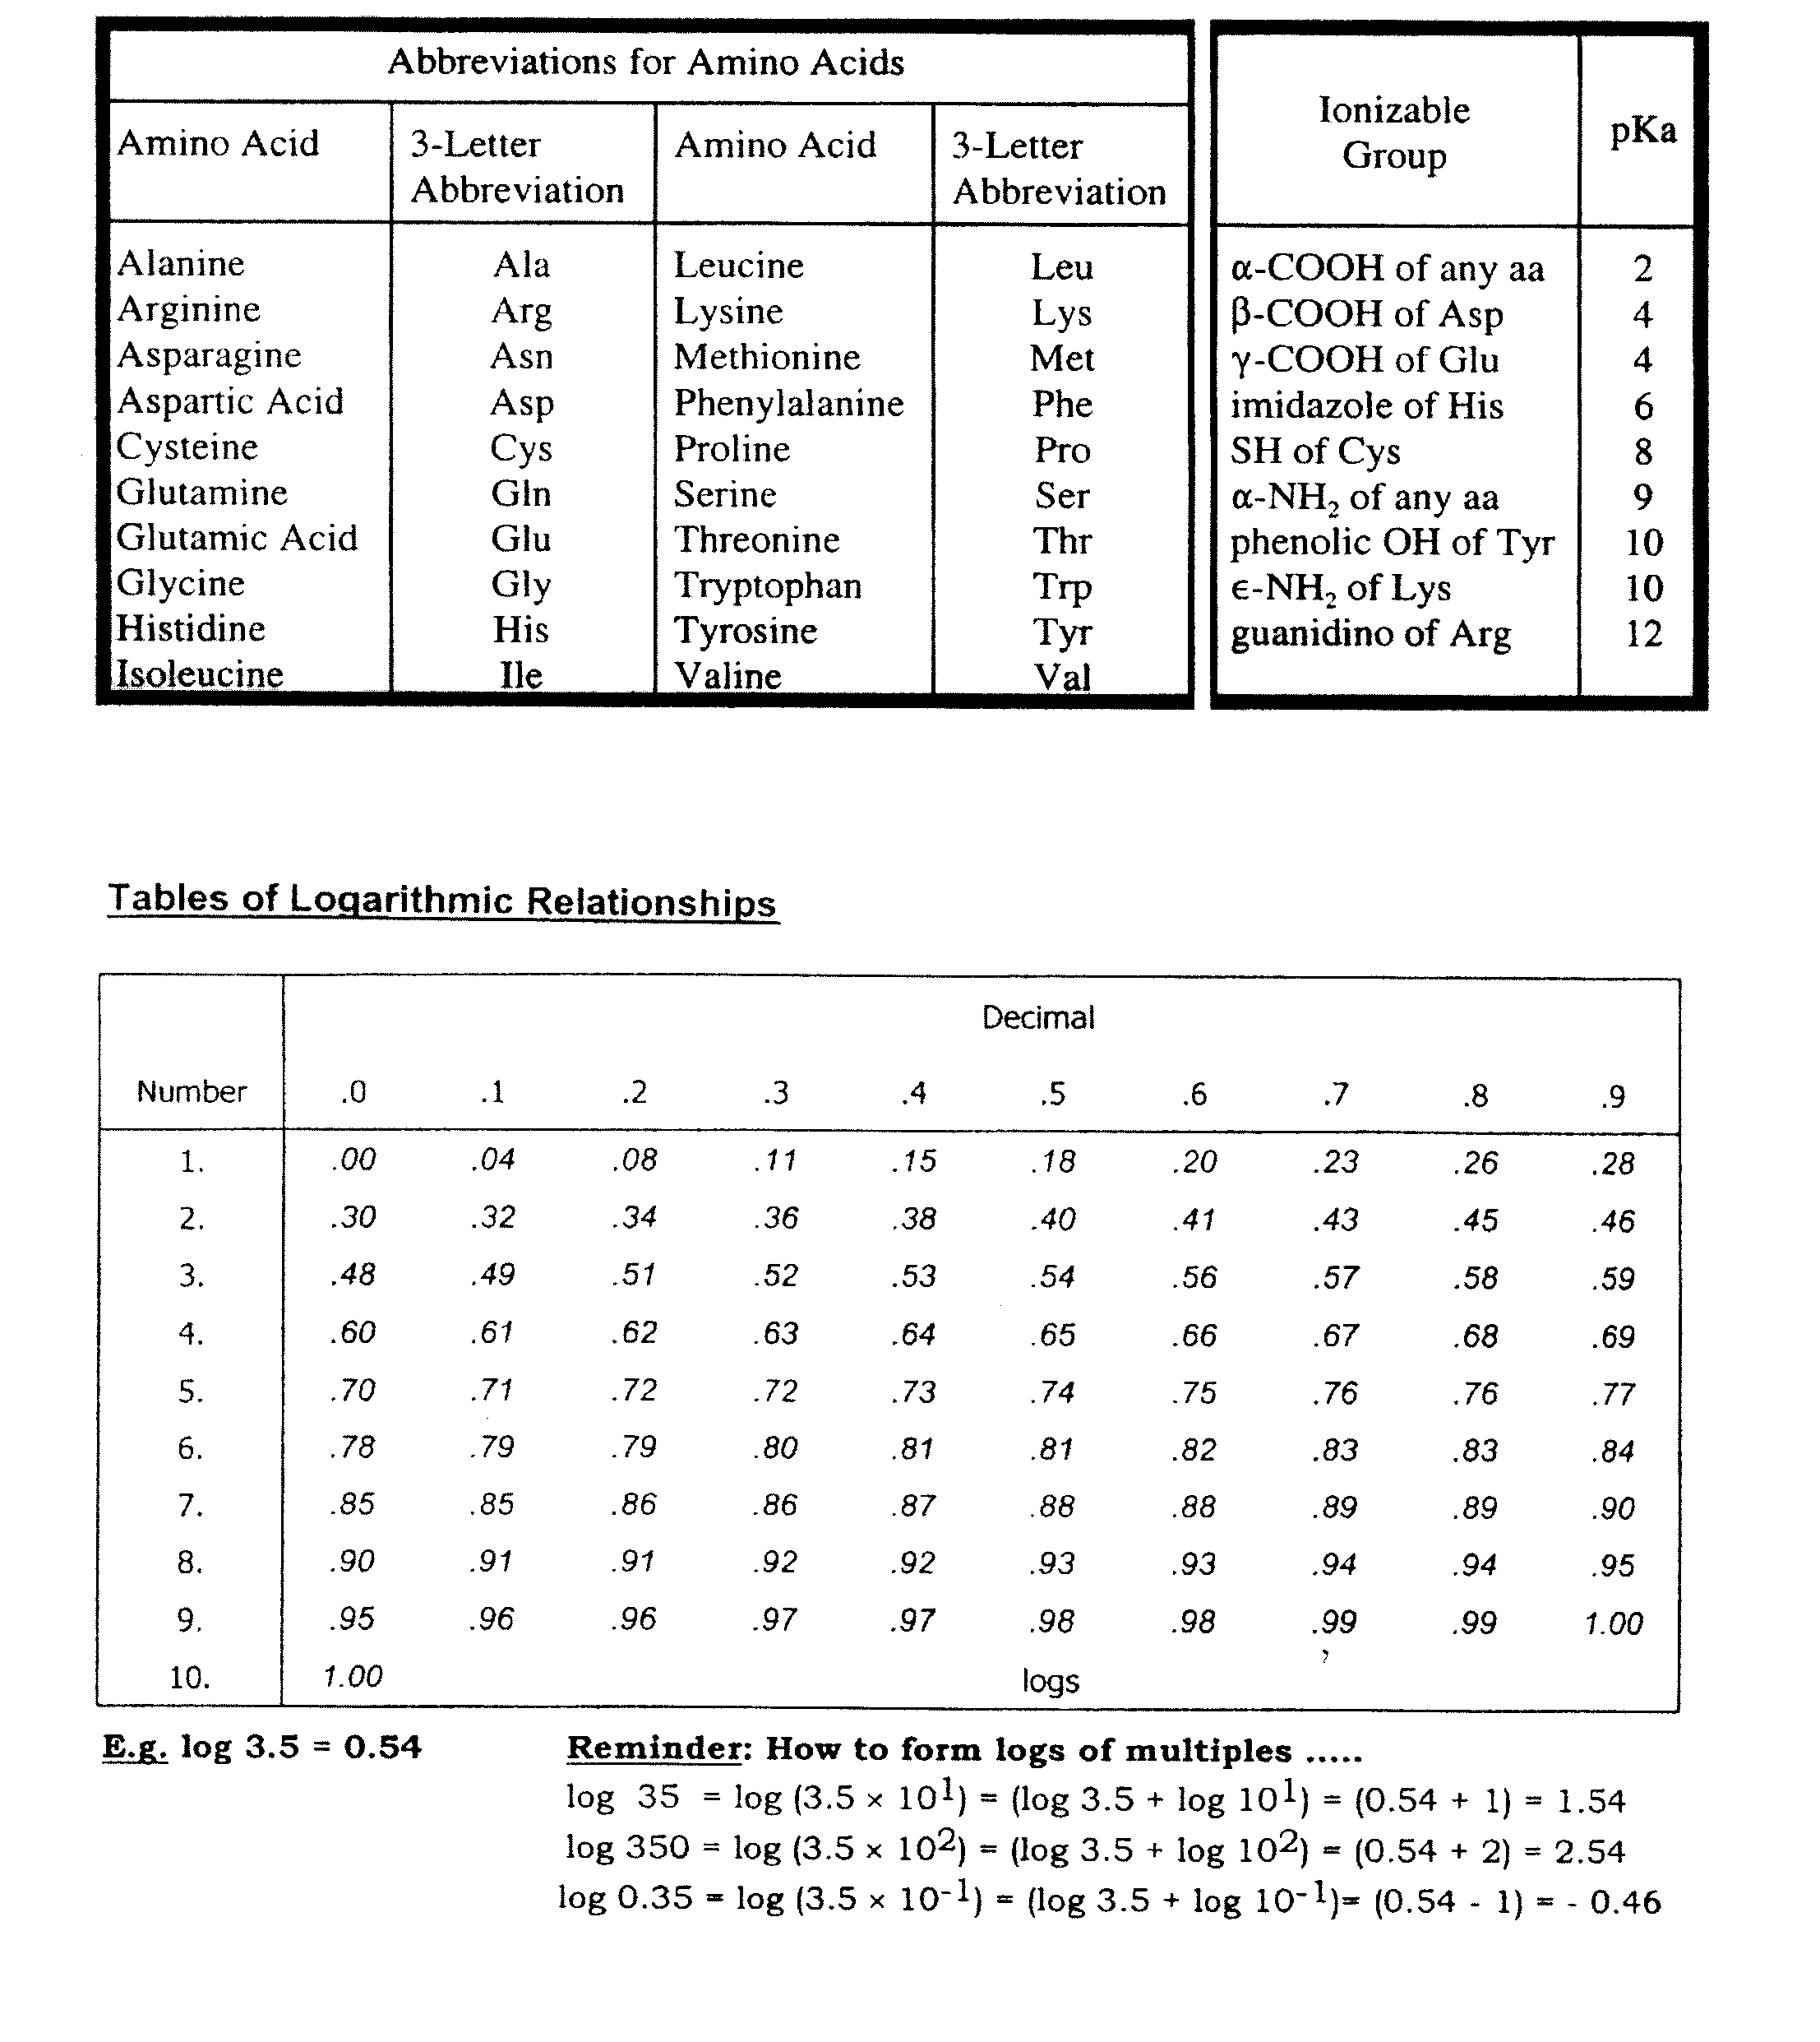

Questions 1-3: The structure of the sweentener Aspartame, consisting of a methyl ester of a dipeptide, is shown below. Some of the carbon atoms in the molecule are numbered, 1 through 6. Use this structure and the numbering system to answer questions 1 - 3.
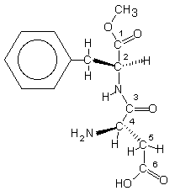

- Which numbered carbon is directly linked in a peptide bond?
A) 1
B) 2
C) 3
D) 4
E) 5

- This molecule, containing naturally occurring amino acids, is in which optical configuration?
A) D, D
B) D, L
C) L, D
D) L, L

- At pH 3 (common pH of soda) what would be the charge of this molecule?
A) +2
B) +1
C) 0
D) -1
E) -2
- Which of the following statements about protein structure is correct?

A) The α-helix is stabilized primarily by ionic interactions between the side chains of amino
acids.
B) The formation of the disulfide bond in a protein requires that the two participating cysteine
residues be adjacent to each other in the primary sequence of the protein.
C) The stability of quaternary structure in proteins is mainly due to covalent bonds among the
subunits.
D) The denaturation of proteins always leads to irreversible loss of secondary and tertiary
structure.
E) The information for the correct folding of a protein is contained in the specific sequence
of amino acids along the polypeptide chain.
- Which of the following best illustrates hydrophobic forces that stabilize the conformation of some proteins?

A) clustering of nonpolar amino acid side chains in the interior of globular proteins.
B) heat denaturation of globular proteins.
C) the unfolding of proteins at low pH.
D) the formation of α-helices.
E) the formation of β-pleated sheets.
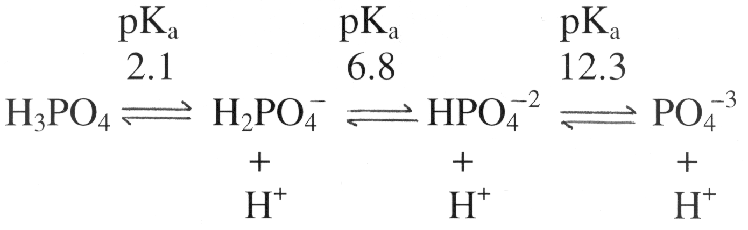

As shown above, phosphoric acid has three ionizable protons, with the pK_{a} values indicated. The buffering capacity of phosphoric acid is LEAST at pH:

A) 2.1
B) 4.6
C) 6.8
D) 7.4
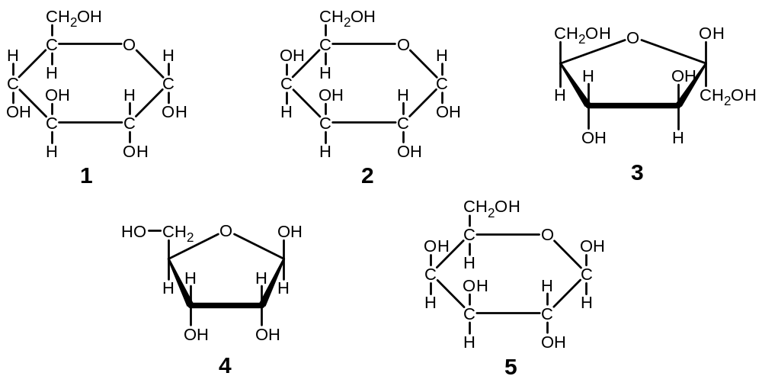 E) 12.3

- Which of the above molecules are anomers?

A) molecules 1 and 2
B) molecules 2 and 5
C) molecules 1 and 5
D) molecules 3 and 4
E) molecules 1 and 4

- Which of the above molecules is a component of ribonucleotides?

A) molecule 1
B) molecule 2
C) molecule 3
D) molecule 4
E) molecule 5
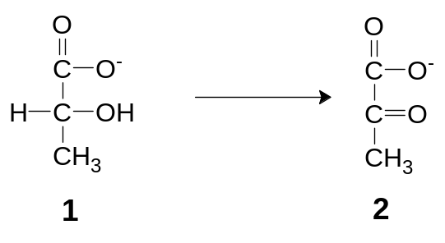

- In the reaction drawn above, what has happened to molecule 1 to convert it to molecule 2?

A) Phosphorylation
B) Oxidation
C) Isomerization
D) Dehydration
E) Reduction

- For the reaction drawn above, what type of enzyme would carry out this reaction?

A) Epimerase
B) Isomerase
C) Hydrolase
D) Kinase
E) Dehydrogenase

Questions 11-14 refer to the diagram below. Identify the letters A - E in the diagram with chemical names. Then, match the chemical name in each question with the appropriate letter.
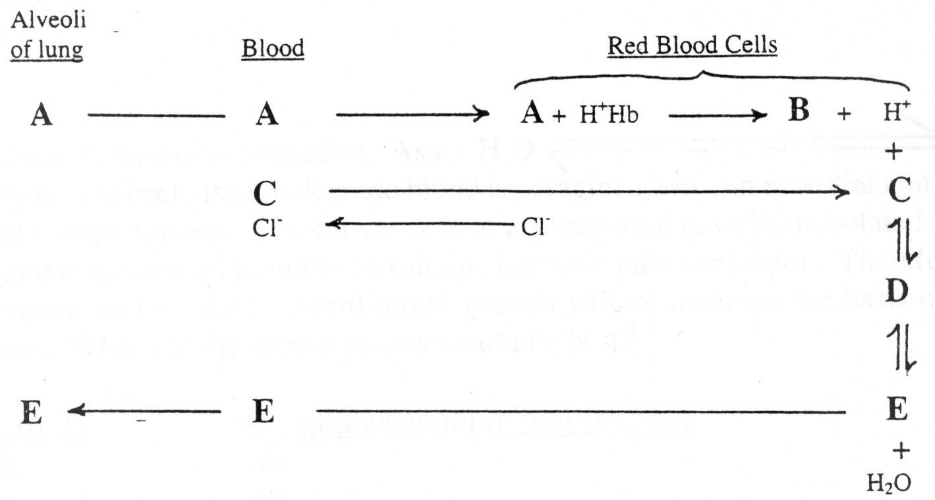

- Carbon dioxide

- Bicarbonate

- Oxygenated hemoglobin

- Carbonic acid

- The differences between hemoglobin and myoglobin include

A) hemoglobin is a tetramer whereas myoglobin is a monomer.
B) hemoglobin exhibits a sigmoidal O₂ saturation curve while myoglobin exhibits a hyperbolic curve.
C) hemoglobin exhibits O₂ binding cooperativity while myoglobin does not.
D) hemoglobin exhibits a lower degree of O₂ saturation at all physiologically relevant partial
pressures of O₂ than does myoglobin.
E) all of the above

- What effect does alkalemia due to hyperventilation have on the oxygen binding affinity of hemoglobin?
A) P₅₀ and oxygen affinity decrease.
B) P₅₀ and oxygen affinity increase.
C) P₅₀ decreases and oxygen affinity increases.
D) P₅₀ increases and oxygen affinity decreases.
E) P₅₀ and oxygen affinity remain the same.

- A common practice of competitive short-distance runners is to breathe rapidly and deeply for about half a minute before running in a 100-meter dash. The purpose of this hyperventilation is to achieve:

A) Metabolic Acidosis
B) Metabolic Alkalosis
C) Respiratory Acidosis
D) Respiratory Alkalosis
E) Acid-base Normalcy

- A 27-year old male is rushed into the emergency room in a coma and experiencing respiratory depression. Data from the clinical biochemistry lab are compared with normal values below. Additional case history indicates the patient is suffering from a narcotic overdose. What is the immediate cause for the low pH value of the blood?

Patient Normal

pH 7.1 7.4
Total CO₂ content 26.4 26 mM
pCO₂ ? 40 mm Hg
[HCO₃⁻] ? 24 mM

(For calculations, use 6.1 for the pK_{a} of bicarbonate buffer and 0.03 mM/mm Hg for the solubility coefficient of CO₂ at 37 ºC.)

A) The narcotic overdose affected the kidney's ability to adjust to an increased [HCO₃⁻].
B) The narcotic overdose affected the kidney's ability to adjust to a decreased [CO₂ (d)].
C) The narcotic overdose led to a decreased respiratory rate, which in turn led to an increase in [CO₂ (d)].
D) The narcotic overdose led to an increased respiratory rate, which in turn led to a decrease in [CO₂ (d)].
E) Utilizing the value of total CO₂ content and the Henderson-Hasselbalch equation, one can conclude
that there is an increase in [HCO₃⁻].

- Repeated laboratory results over the past three weeks suggest that your patient suffers from acidemia. In the most recent visit, blood tests yielded the following results (normal values in parenthesis):

pH = 7.34 (7.4)
pCO₂ = 60 mm Hg (40 mm Hg)
[HCO₃⁻] = 31 mM (24 mM)

The problem is most likely due to:

A) hyperventilation due to hypoxia
B) vomiting and nasogastric suction
C) chronic respiratory center depression and central hypoventilation
D) diabetic ketoacidosis
E) none of the above

- A substrate S can be degraded by two different isozymes (#1 and #2), both obeying Michaelis-Menten kinetics. The K_{m} for isozyme #1 is 0.1 mM and the corresponding value for isozyme #2 is 10 mM. Both isozymes have the same V_{max}. If [S] = 5 mM, which of the following statements is correct?

A) Isozyme #1 will degrade S faster than isozyme #2.
B) Isozyme #2 will degrade S faster than isozyme #1.
C) Isozyme #1 will degrade S at a rate equal to half of its maximal velocity.
D) Isozyme #2 will degrade S at a rate equal to half of its maximal velocity.
E) Isozyme #2 will degrade S at its maximal velocity.

In the figure below, the solid line shows the dependence of the rate of an enzyme catalyzed reaction v (μmol/min) as a function of the substrate concentration [S] (mM). Also shown (dotted line) is the dependence of the rate on substrate concentration in the presence of an inhibitor (at a concentration of 2 mM). Questions 21-23 refer to this figure.
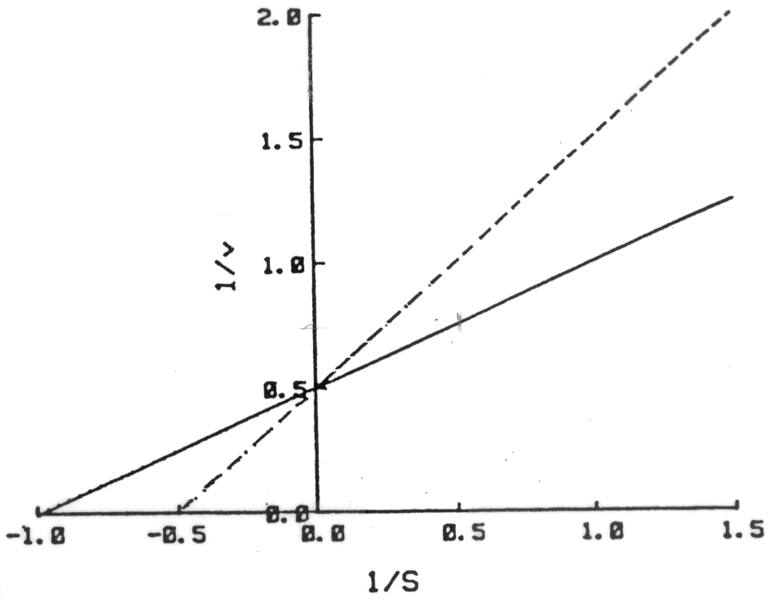

- Regarding the activity of the enzyme in the absence of the inhibitor (solid line), which of the following conclusions is correct?

A) The V_{max} of the enzyme is 0.5 μmol/min.
B) The K_{m} of the enzyme is 2 mM.
C) When [S] = 2 mM, v = 2 μmol/min.
D) V_{max}/K_{m} = 0.5 μmol/min (mM)⁻¹
E) When [S] = 1 mM, v = 1 μmol/min.

- In the presence of the inhibitor (dotted line), the K_{m}' (apparent K_{m}) of the enzyme, in units of mM, is:

A) 0.25
B) 0.5
C) 1.0
D) 2.0
E) 4.0

- On the basis of the graphs shown above, which of the following statements correctly describes the nature of the inhibitor/inhibition?

A) The inhibitor is competitive.
B) The inhibitor is non-competitive.
C) The inhibitor acts as a positive effector.
D) The inhibitor is likely to bind to a site distinct from the active site of the enzyme.
E) The inhibitor is likely to act as an allosteric effector.

- All of the following statements about allosteric enzymes are true except:

A) allosteric enzymes usually contain more than one subunit
B) allosteric enzymes display Michaelis-Menten kinetics
C) allosteric enzymes are often subject to feedback inhibition
D) allosteric enzymes are often regulated by ligands binding to sites different than the active sites
E) allosteric effectors can act to either increase or decrease affinity for substrate at the active sites

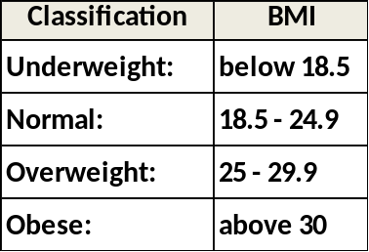
- Using the table to the right, what would be the classification of a medical student who weighs 130 lbs and
is 5’10”?

BMI = (weight in lbs x 704)/(Height in inches)²

A) Underweight
B) Normal
C) Overweight
D) Obese

Questions 26 -28 refer to the following five structures (I – V)
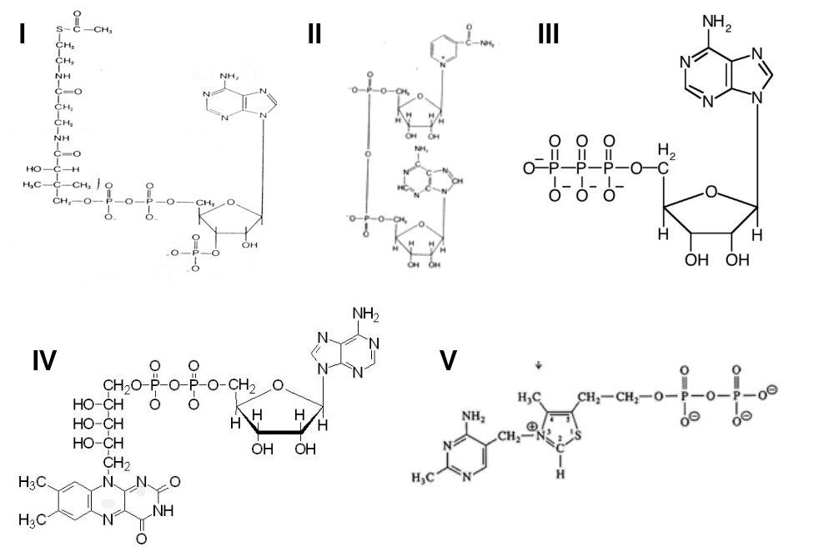

- Which of the structures is not a B vitamin?

A) I
B) II
C) III
D) IV
E) V

- Which of the above structures depicts a coenzyme derivative performing its role as a carrier of carbon chains?

A) I
B) II
C) III
D) IV
E) V

- A patient is brought into the clinic and has been diagnosed with suffering from a severe deficiency of the vitamin that gives rise to the coenzyme derivative depicted in V. What symptoms would you expect to see in this patient?

A) Pernicious anemia
B) Scaly dermatitis and glossitis of the tongue
C) Pellegra presented as dermatitis, diarrhea, and dementia
D) Scurvy presented as loss of teeth and bleeding gums and mucus tissues
E) Beri Beri presented as cardiovascular abnormalities, muscle weakness, and mental confusion
- Which of the following statements regarding catabolic and anabolic processes is true?

A) Anabolic processes create ATP
B) Muscle contraction and ion transport are types of anabolic processes
C) Carbohydrates and proteins are broken down in anabolic processes
D) Catabolism is considered the utilization phase of the energy cycle
E) Absorption, breakdown, and oxidation are the three phases of anabolic processes
- What is the ΔG⁰’ of the reaction:

ATP ⬄ Pi + ADP

If the equilibrium concentrations are [ATP] = 10 M, [Pi] = 0.1 M, [ADP] = 10 M and given that
ΔG’ = ΔGº’ + 1.4log[products]/[reactants]

A) -1.4 kcal/mol
B) -2.8 kcal/mol
C) +2.8 kcal/mol
D) -0.14 kcal/mol
E) +1.4 kcal/mol
- Consider the following reactions:

A ⬄ B ΔGº’ = +5.3 kcal/mol
C ⬄ D ΔGº’ = -0.8 kcal/mol

If a single enzyme is capable of coupling the two reactions what would the free energy change (ΔG’) of the reaction: A + C ⬄ B + D be if [A] = 1.0 M, [B] = 0.1 M, [C] = 10 M and [D] = 0.1 M
ΔG’ = ΔGº’ + 1.4log[products]/[reactants]

A) +0.3 kcal/mol
B) -1.7 kcal/mol
C) +1.7 kcal/mol
D) +8.7 kcal/mol
E) +1.1 kcal/mol

- All of the following statements about metabolism are correct except?

A) Insulin, glucagon, and epinephrine play central roles in metabolic control
B) Your basic metabolic rate (BMR) is dependent upon your age and gender
C) Your kidneys are the primary organ of metabolism
D) Acetyl CoA is produced from the breakdown of carbohydrates, fats, and protein
E) Daily energy expenditures are comprised of BMR, physical activity, and diet-induced thermogenesis

END OF EXAMINATION Tear off this sheet and save to check your answers.

Please remember to:

- Write the letter corresponding to your FORM in the appropriate place on the answer sheet.
- SIGN AND RETURN YOUR EXAMINATION to an instructor before leaving the exam room.

FORM: A

1. _______
2. _______
3. _______
4. _______
5. _______
6. _______
7. _______
8. _______
9. _______
10. _______
11. _______
12. _______
13. _______
14. _______
15. _______
16. _______
17. _______
18. _______
19. _______
20. _______
21. _______
22. _______
23. _______
24. _______
25. _______
26. _______
27. _______
28. _______
29. _______
30. _______
31. _______
32. _______

