**Exam Procedures:**

**STEP 1 - NAME (*Print clearly*) _________________ ____________________________**

*(first) (last)*

**STEP 2 – Fill in your answer sheet, using a #2 scoring pencil, as follows:**

* Your Student PID Number (excluding “A”)
* Your last name and first name
* Course ID in “subject” …… **this is** **BMB 514 Exam #2**
* Date …… **10/8/12**
* Exam form in “period” …..**this is form A**
* By signing this coversheet for this exam, the student certifies that he/she has adhered to the policies of academic honesty in the performance of this exam.

_____________________________________

Signature

**STEP 3 - Read these instructions:**

* Make sure your exam has **32** questions.
* Page 2 of this exam contains information that may be useful to you: (a) abbreviations for the amino acids; (b) pKa values of functional groups; and (c) table of logarithms.
* Read each question very carefully. Choose the single, best answer and mark this answer on your answer sheet. No points will be added for correct answers which appear on the exam page but not on the answer sheet.
* A simple calculator is supplied for your use during this exam. No other electronic or computational devices are to be used. Turn off cell phones; keep them out of sight.
* The proctors have the authority/responsibility to assign any student a different seat at any time, without implication and without explanation, before or during the examination, as they deem necessary. Accomplish any relocation quietly and without discussion.
* We will not answer questions of clarification. However, if you think there is an error on your exam, summon an exam proctor.
* When you finish, place all exam materials (except the tear sheet) into the manila envelope. When you leave the exam room, please turn in your envelope to the proctors. Once you exit the auditorium, please leave the area. Hallway conversations disturb those still taking the exam.
* There will be answer keys to this exam posted on the course website by 5:00 p.m. the day of the exam. You may wish to copy your responses from your answer sheet onto the answer grid on the LAST page of this exam so that you can check your results. You can tear off the last page and take it with you.
* We will close the exam promptly at **9:10 a.m.** At the announcement of the examination end time, the examination and scantron and images (if provided as part of the examination) must immediately be placed into the manila envelope provided.

***STEP 4 – Wait until instructed to proceed with the exam!***

# INFORMATION THAT MAY BE USEFUL FOR THE EXAM

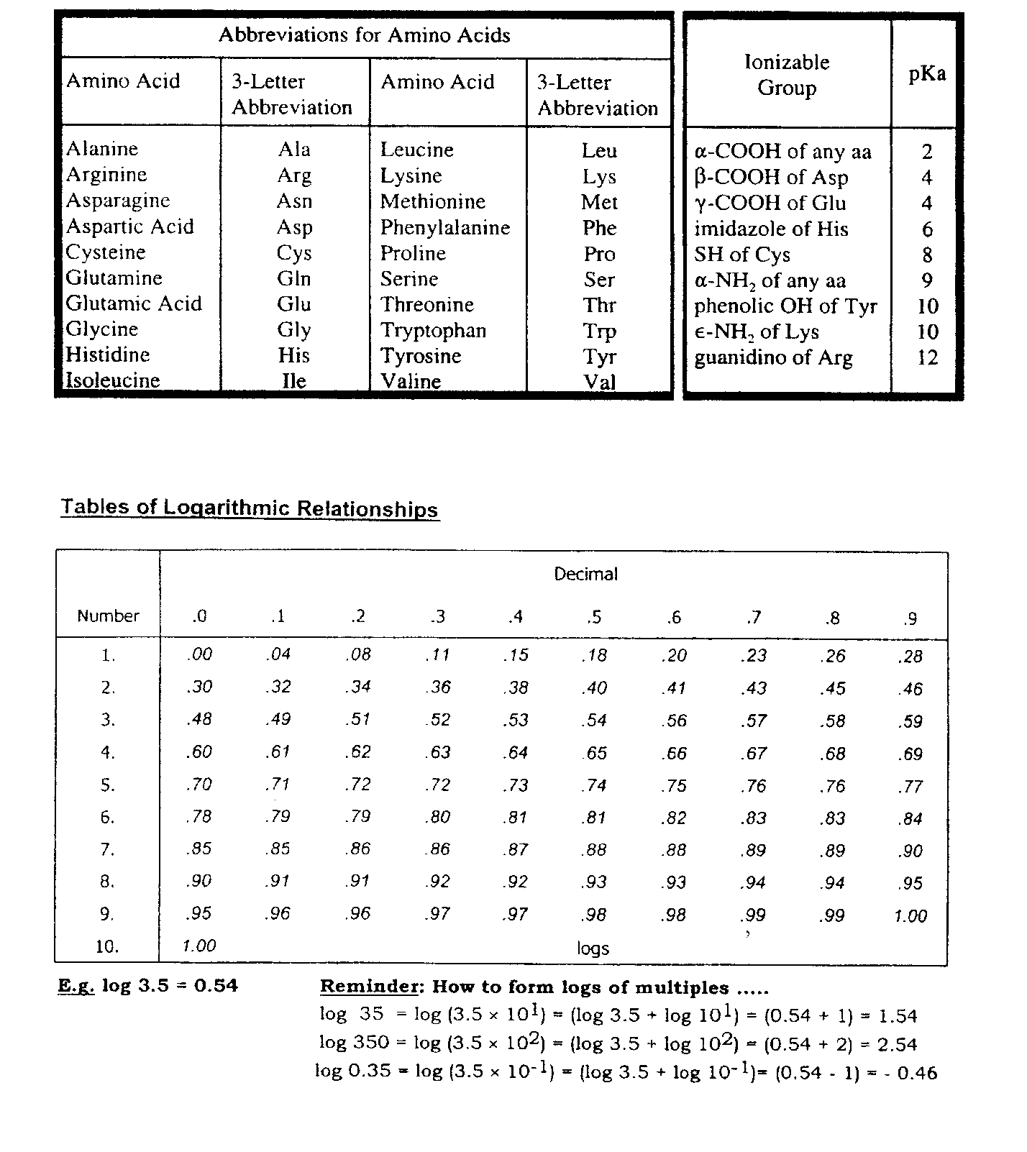

The first 5 questions deal with the figure below. Enzymes are labeled V through Z (Black boxes), metabolites are labeled 1 through 4 (Circles) and compounds, used or released during catalysis are labeled A – E. You might find it useful to identify all the compounds and enzymes before attempting to answer the questions.



1. Patients with deficiencies in enzyme X can have which of the following pathologies?
2. Increased exercise capacity
3. Oxidative stress-induced hemolysis
4. Fasting-induced hyperglycemia
5. Hepatomegaly and extended abdomen
6. Normal glycogen levels but with short branches
7. Patients with deficiencies in enzyme W can have which of the following pathologies?

A) Increased exercise capacity

B) Oxidative stress-induced hemolysis

1. Fasting-induced hyperglycemia
2. Hepatomegaly and extended abdomen
3. Normal glycogen levels but with short branches
4. Which of the following are enzymes that catalyze essentially irreversible reactions within the cell?
5. X and Y
6. Y and Z
7. V and Y
8. V and X
9. W and Z
10. Which compound (letters A-E) represents ATP?
11. Which metabolite can serve as a substrate for the enzyme that catalyzes the committed step of glycolysis AND as a substrate for the transketolases of the pentose phosphate pathway?
12. Metabolite #1
13. Metabolite #2
14. Metabolite #3
15. Metabolite #4
16. Arsenic is capable of inhibiting enzymes that utilize free sulfhydryl groups for their enzymatic activity. Which of the following enzymes would be negatively impacted if you drank arsenic-contaminated water?
17. Pyruvate kinase
18. Pyruvate dehydrogenase complex
19. Pyruvate Carboxylase
20. Citrate synthase
21. HMG CoA synthase
22. The conversion of malate to oxaloacetate is an unfavorable reaction (Go’ = + 7.0 kcal/mol). Which of the following correctly describes malate dehydrogenase, the enzyme responsible for carrying out this reaction?
23. Produces 1 mole of ATP for every mole of oxaloacetate produced
24. The reaction can become favorable within the cell due to the activity of citrate synthase
25. The reaction is inhibited by high concentrations of NAD+
26. Utilizes biotin as a cofactor
27. The product, oxaloacetate, is transported out of the matrix to be used in gluconeogenesis

The following 3 questions deal with the patient described below:

A full term female infant who has failed to gain weight and experiences frequent metabolic acidosis, was brought into the hospital. Examination showed a decrease in muscle mass, severe head lad, and hypotonia (low muscle tone). Following her admittance into the hospital her test results were as follows:

1. After consultation with the family, it was determined the patient suffers from a detrimental mutation in a key metabolic enzyme. Dietary carbohydrate restriction and a ketogenic diet did not alleviate the patient’s symptoms. Lipoic acid partially corrects the defect and based on this information, you suspect that the mutation affects which of the following enzymes?
2. Pyruvate kinase
3. Lactate dehydrogenase
4. Citrate synthase
5. Pyruvate carboxylase
6. Pyruvate Dehydrogenase
7. Based solely on the lactic and pyruvic acidemia and high alanine levels, (i.e. not knowing that lipoic acid ameliorated the symptoms) which of the following matches another therapy strategy and the correct rationale for attempting it with this patient?

**Therapy** **Rationale**

1. Thiamine Correct a defect in E1 of pyruvate dehydrogenase
2. Niacin Correct a defect in malate dehydrogenase
3. Biotin Correct a defect in E1 of pyruvate dehydrogenase
4. Thiamine Correct a defect in pyruvate carboxylase
5. Niacin Correct a defect in lactate dehydrogenase
6. Knowing that the patient was helped by lipoic acid and that a ketogenic diet was not an effective treatment strategy, which of the following enzymes might you also expect to be impacted in this patient?
7. -ketoglutarate dehydrogeanse
8. Succinate dehydrogeanse
9. Fumarate hydratase
10. Citrate synthase
11. Cytochrome c oxidase
12. A Michigan State researcher was recently brought into the emergency room near death. You quickly deduce that the researcher was exposed to a near lethal dose of antimycin during the course of his studies on the fungus cultivating attine ants; they use the antibiotic to control pathogenic fungi. If you could isolate some mitochondria from the patient which of the following would correctly describe the state of the electron transport chain (ETC) intermediates and the effect of 2,4-dinitrophenol on the organelle’s O2 consumption rate

**ETC Intermediate 2,4DNP effect on O2 consumption**

1. Increase levels of reduced cytochrome C Unchanged
2. Increased levels of ubiquinol Unchanged
3. Decreased levels of ubiquinol Unchanged
4. Decreased levels of reduced cytochrome C Increased
5. Increased levels of NADH Increased
6. Following the consumption of a meal consisting of a baked potato with caramel sauce and M & M sprinkles, which would best describe the state of the reciprocal regulation between glycogen phosphorylase and glycogen synthase while sitting on the couch watching “The Usual Suspects”?

**cAMP Levels** **Glycogen Synthase** **Glycogen Phosphorylase**

1. High phosphorylated and inactive phosphorylated and active
2. Low unphosphorylated and active unphosphorylated and inactive
3. High phosphorylated and active phosphorylated and inactive
4. Low phosphorylated and active phosphorylated and inactive
5. High unphosphorylated and active unphosphorylated and inactive
6. A patient suffering from carnitine deficiency will experience which of the following?
7. An inability to translocate fatty acyl CoA across the outer mitochondrial membrane
8. An increased rate of -oxidation
9. Sequestration of fatty acyl CoA within the matrix of the mitochondria
10. Accumulation of fatty acids within various tissues, such as muscles.
11. Lactic acidosis caused by increased reliance on carbohydrate metabolism.
12. Which of the following statements regarding Complex IV in the electron transport chain is **INCORRECT**?
13. It accepts electrons from reduced coenzyme Q (aka ubiquinol)
14. It is the final complex in the electron transport chain
15. It utilizes molecular oxygen as an electron acceptor
16. It is capable of pumping protons across the inner membrane of the mitochondria
17. It produces water
18. What are the products of beta-oxidation of a C19 fatty acid?

A) 1 propionyl CoA, 8 acetyl CoA, 8 FADH2, and 8 (NADH + H+)

B) 9 acetyl CoA, 8 FADH2, 8 (NADH + H+)

C) 9 acetyl CoA, 8 FADH2, 9 (NADH + H+),

D) 1 propionyl CoA, 8 acetyl CoA, 9 FADH2, and 9 (NADH + H+)

E) 1 propionyl CoA, 7 acetyl CoA, 8 FADH2, and 8 (NADH + H+)

1. Which of the following correctly matches the molecule and its impact on -oxidation of fatty acids

**Molecule** **Impact on -oxidation**

1. NADH Activates via stimulation of -hydroxyacyl CoA dehydrogenase
2. Acetyl CoA Inhibits via stimulation of -ketothiolase
3. Glucagon Activates via stimulation of lipases within adipose cells
4. Malonyl CoA Activates via stimulation of carnitine acyltransferase I
5. Insulin Activates via stimulation of 3-ketothiolase (aka -ketothiolase)
6. All of the following are required to transport acetyl CoA produced within the matrix of the mitochondria to the cytosol **EXCEPT**
7. Tricarboxylate transporter
8. Citrate lyase
9. Malate
10. Pyruvate transporter
11. Oxaloacetate transporter
12. Which of the following correctly describes linoleic or linolenic acid?
13. They can be produced from palmitate via desaturases
14. Are readily converted to arachidonic acid
15. Linoleic acid is an example of an omega-3 fatty acid
16. Are trans fats that have negative impact on heart health
17. Can be produced from leukotrienes via malonyl CoA transferase
18. Which of the following is unique to the *de novo* triacylglycerol synthesis pathway as compared to the *de novo* glycerophospholipid synthesis pathway?
19. Glycerol kinase
20. Acyl transferase
21. Glycerol 3-phosphate dehydrogenase
22. Phosphatidate phosphatase
23. Phosphatidate cytidylyl transferase
24. A patient is brought into the office suffering from complications in Cori’s disease (Type III, glycogen storage disease, amylo-1,6-glucosidase (debranching) deficiency). Which of the following would you expect to find in terms of amount and structure of the patient’s glycogen stores?

**Amount** **Structure**

A) Increased normal structure

B) Increased short outer branches

C) Normal minimal outer branches

D) Normal very long branches

E) Increased very long branches

1. Which of the following statements correctly describes cholesterol synthesis?

A) HMG-CoA is produced from mevalonate pyrophosphate.

B) HMG-CoA synthase is the target of the statin drugs.

C) -ketothiolase catalyzes the committed step in cholesterol biosynthesis.

D) Involves the sequential condensation of a 6 carbon unit onto mevalonate.

E) Squalene, the cholesterol precursor, can also be used in the synthesis of ubiqinone

The next 2 questions relate to the following clinical case:

A three year old female child suffers from repeated vomiting, lethargy, and in extreme cases, comas. Following an almost 4 hour fast, the infant is extremely lethargic and her blood glucose levels are 3.0 mM (normal is 3.6 – 6 mM). Lab results also show she has low circulating levels of ketone bodies, and high levels of dicarboxylic acids and hexanoylglycine (a metabolite formed from a six-carbon fatty acid) in her urine. You quickly realize that the patient is suffering from medium-chain acyl CoA dehydrogenase deficiency (MCAD).

1. What is the main reason for the patient’s hypoglycemia?
2. Inhibition of gluconeogenesis by the high circulating levels of dicarboxylic acids
3. The conversion of acetyl CoA to pyruvate is inhibited by low circulating glucose
4. Medium-chain acyl CoA dehydrogenase is necessary for the activation of fructose 2,6-bisphosphatase
5. The inability of -oxidation to release acetyl CoA, a positive regulator of pyruvate carboxylase
6. The transport of malate out of the mitochondria, is inhibited by dicarboxylic acid
7. Which of the following is likely responsible for the low circulating ketone bodies?
8. The patient cannot activate ketone body synthesis because of high levels of oxaloacetate caused by the hypoglycemia
9. The patient is not efficiently releasing ketone bodies from her liver because of lack of acetyl CoA for their synthesis
10. The hypoglycemia is causing an NADH deficiency in the matrix thus inhibiting the production of 3-hydroxybutyrate
11. The inhibition of HMG-CoA synthase by glucagon caused by hypoglycemia
12. The high concentration of medium chain fatty acids is inhibiting the production of acetoacetyl CoA.
13. Premature infants are at a risk of respiratory distress syndrome, in part, because their lungs are not able to produce dipalmitoylphosphatidyl choline (DPPC). Which of the following statements correctly describe this phospholipid or its synthesis?
14. Phosphatidate phosphorylase inhibition will inhibit its synthesis
15. Its synthesis is dependent upon activation of phosphatidate by phosphatidate cytidylyl transferase
16. Giving the patient daily doses of glucagon will increase the production of DPPC
17. The addition of the two palmitates to the glycerol 3-phosphate backbone is energy independent
18. The glycerol 3-phosphate backbone can only be produced by the liver-specific glycerol kinase
19. Which of the following correctly describes a step of lipid digestion and absorption?
20. The emulsification of dietary lipids happens in the stomach
21. Mixed micelles are primarily composed of fatty acids larger than 12 carbons
22. The pancreas produces lipases responsible for breaking down triacylglycerides
23. Lipid-soluble vitamins are digested in mixed micelles
24. Phospholipases are released by the gall bladder.
25. Which of the following correctly describes cholesterol, its processing, or its transport?
26. The cell uses the same pool of HMG-CoA for cholesterol and ketone body synthesis
27. Cholesterol esterification increases its polarity making it more water soluble
28. Low density lipoproteins are called bad cholesterol because they can esterify cholesterol
29. High density lipoproteins are solely responsible for cholesterol excretion
30. All cholesterol is transported in the esterified form.
31. A patient with Von Gierke’s disease (Glycogen storage disease Type I) is admitted to the hospital suffering severe metabolic acidosis. Which of the following probably contributed to the severe acidosis?

A) Over production of lactic acid caused by increased glycolysis

B) Over production of ketone bodies as the patient turns to fat stores for energy

C) Decreased uric acid excretion caused by transporter competition with lactic acid

D) A and B

E) All of the above

1. Which of the following statements regarding chylomicrons is correct?
2. Chylomicrons are synthesized and stored in the gall bladder
3. Chylomicrons can transport triacylglycerides but not phospholipids or lipid soluble vitamins
4. Chylomicrons are considered the most dense lipoprotein in human plasma
5. Chylomicrons are the only lipoprotein that express apoprotein E
6. Hyperchylomicronemia can be caused by a deficiency in lipoprotein lipases
7. Which of the following correctly describes the regulation of the synthesis and uptake of cholesterol?

A) Insulin activates HMG-CoA reductase via a phosphatase.

B) Cholesterol increases HMG-CoA reductase gene expression.

C) Cholesterol will increase the expression of low density lipoproteins.

D) Cholesterol will decrease the rate of breakdown of HMG CoA reductase.

E) Cholic acid and cholesterol have opposite regulatory effects on HMG-CoA Reductase.

30) How will high concentrations of AMP, citrate and fructose 2,6-bisphosphate, respectively, tend to affect the rate of glycolysis?

**AMP**  **citrate**  **fructose 2,6-bisphosphate**

A) increase increase increase

B) increase decrease increase

C) decrease increase increase

D) decrease decrease increase

E) decrease increase decrease

31) Which of the following correctly describes the malate-aspartate shuttle?

A) During gluconeogenesis malate is moving into the cytoplasm

B) It transports NADH from the cytosol to the matrix

C) It is essentially irreversible

D) It uses an -ketoglutarate-aspartate cotransporter to maintains carbon balance

E) It maintain glyceraldehyde 3 phosphate dehydrogenase activity under anaerobic conditions

32) Which of the following statements regarding ketone bodies is correct?

A) The position of the keto group on the β-carbon of -hydroxybutyrate allows it to spontaneously decarboxylate to form acetone.

B) Tissues can utilize acetone and β-hydroxybutyrate as fuel sources.

C) HMG-CoA synthase is an ATP-dependent enzyme.

D) The reduction of acetoacetate to β-hydroxybutyrate in the liver involves the corresponding oxidation of NADPH + H+ to NADP+.

E) HMG-CoA lyase produces acetoacetate, the first ketone body formed.

END OF EXAMINATION - Tear off this sheet and save to check your answers.

* You may write in your answer to each question on this sheet. DO NOT make any other marks on this sheet. If there are any extraneous marks on this page it will be confiscated.
* Only the answer on the scantron is the official answer. **WE CANNOT USE THE ANSWERS ON THIS TEAR OFF SHEET TO DETERMINE YOUR GRADE.**

**Please remember to:**

* Write in the **letter of your form** in the area titled “Period” on the exam scantron.
* **Return your examination** in the envelope providedto a proctor **before leaving the exam room**.

FORM: A

1. _____

2. _____

3. _____

4. _____

5. _____

6. _____

7. _____

8. _____

9. _____

10. _____

11. _____

12. _____

13. _____

14. _____

15. _____

16. _____

17. _____

18. _____

19. _____

20. _____

21. _____

22. _____

23. _____

24. _____

25. _____

26. _____

27. _____

28. _____

29. _____

30. _____

31. _____

32. _____