**Exam Procedures:**

**STEP 1 - NAME (*Print clearly*) _________________ ____________________________**

*(first) (last)*

**STEP 2 – Fill in your answer sheet, using a #2 scoring pencil, as follows:**

* Your Student PID Number (excluding “A”)
* Your last name and first name
* Course ID in “subject” …… **this is** **BMB 514 Exam #1**
* Date …… **9/14/12**
* Exam form in “period” …..**this is form A**
* By signing this coversheet for this exam, the student certifies that he/she has adhered to the policies of academic honesty in the performance of this exam.

_____________________________________

Signature

**STEP 3 - Read these instructions:**

* Make sure your exam has **32** questions.
* Page 2 of this exam contains information that may be useful to you: (a) abbreviations for the amino acids; (b) pKa values of functional groups; and (c) table of logarithms.
* Read each question very carefully. Choose the single, best answer and mark this answer on your answer sheet. No points will be added for correct answers which appear on the exam page but not on the answer sheet.
* A simple calculator is supplied for your use during this exam. No other electronic or computational devices are to be used. Cell phones must be off (not on vibrate) and stored with your bags/backpacks/other materials.
* The proctors have the authority/responsibility to assign any student a different seat at any time, without implication and without explanation, before or during the examination, as they deem necessary. Accomplish any relocation quietly and without discussion.
* We will not answer questions of clarification. However, if you think there is an error on your exam, summon an exam proctor.
* When you finish, place the scantron and exam booklet into the manila envelope. When you leave the exam room, please turn in your envelope to the proctors. Once you exit the auditorium, please leave the building. Hallway conversations disturb those still taking the exam.
* There will be answer keys to this exam posted on the course website by 5:00 p.m. the day of the exam. You may wish to copy your responses from your answer sheet onto the answer grid on the LAST page of this exam so that you can check your results. You can tear off the last page and take it with you.
* We will close the exam promptly at **9:10 a.m.** At the announcement of the examination end time, the examination and scantron and images (if provided as part of the examination) must immediately be placed into the manila envelope provided.

***STEP 4 – Wait until instructed to proceed with the exam!***

# INFORMATION THAT MAY BE USEFUL FOR THE EXAM

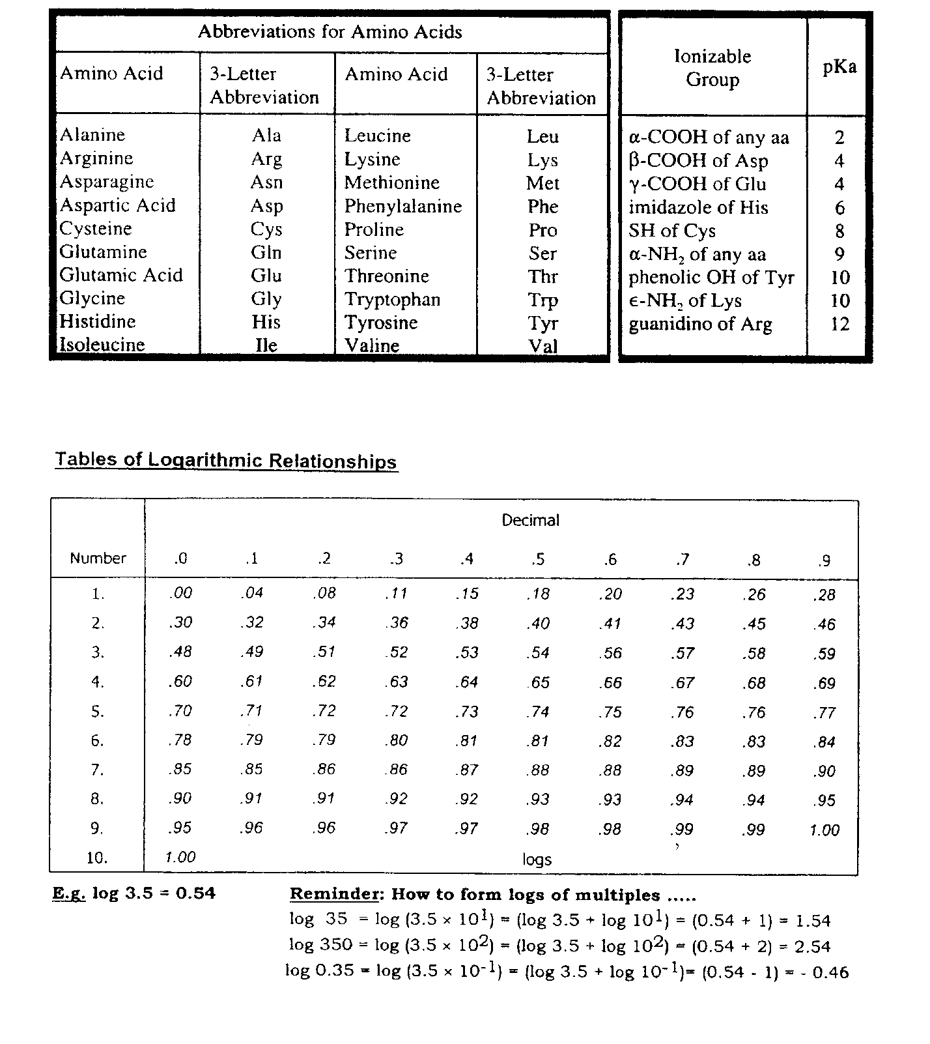

**Questions 1-4 refer to the structural formula shown below.**

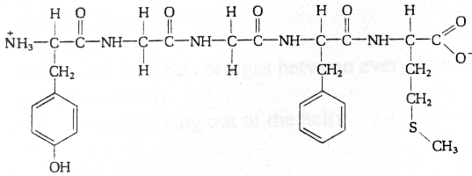

1) This molecule:

A) contains three peptide bonds

B) contains methionine with a free α-amino group

C) contains phenylalanine with a free α-carboxyl group

D) contains cysteine with a free α-carboxyl group

E) contains tyrosine with a free α-amino group

2) Considering only the **side chains** of amino acids in this molecule, which one can participate in hydrogen bonding as a **donor**?

A) amino acid #1

B) amino acid #2

C) amino acid #3

D) amino acid #4

E) amino acid #5

3) This molecule can serve as an effective buffer over the pH range 9.5-10.5. The buffering power over this pH range is due to which amino acid?

A) amino acid #1

B) amino acid #2

C) amino acid #3

D) amino acid #4

E) amino acid #5

4) Which of the primary amino acids in the molecule can undergo post-translational modification to give rise to a secondary amino acid?

A) amino acid #1

B) amino acid #2

C) amino acid #3

D) amino acid #4

E) amino acid #5

**TwoAcidBaseEquilibira.12.tifFor question 5, use the information provided below.**

5) In a venous blood sample, the ratio of [HPO4-2]/[H2PO4-] =2. In this same blood sample, what would be the ratio of [HCO3-]/[CO2(d)]?

A) 20:1

B) 15:1

C) 10:1

D) 5:1

E) 1:1

6)   **East Lansing, MI Vail, CO**

(near sea level)(~8,000 ft above sea level)

**________________** **______________________**

ambient pO2 159 mm Hg 95 mm Hg

tracheal pO2 149 86

alveolar pO2 105 50

arterial pO2 100 45

Information on oxygen pressures are provided above for Michigan and Colorado. You leave East Lansing

for a holiday skiing trip. Two days after arriving at Vail, the best prediction for [2,3-diphosphoglycerate]

and P50 for your body is:

(The symbols, ↑, ↓, and ↔ represent increase, decrease, and remain the same, relative to Michigan.)

**[2,3-diphosphoglycerate]** **P50 (mmHg)**

A) ↑ ↑

B) ↑ ↓

C) ↔ ↔

D) ↓ ↓

E) ↓ ↑

The next **two** questions (7-8) refer to the diagram below on the dynamics of O2 and CO2 at the peripheral tissue (e.g. big toe). Identify the letters **A - F** in the diagram with chemical names. The number **1** refers to an enzyme, whose substrates and product should help you in deciphering some of the letters in **A** - **F**. This is "Be Kind to Your Name Week": the letter F corresponds to O2.  Then match the chemical name in each question with the appropriate letter.

HbCO2.12.tif

7) carbon dioxide

8) bicarbonate

9) Several oxygen saturation curves are shown in the figure below. Assuming that curve **3** corresponds to the oxygen saturation curve of hemoglobin in the erythrocytes of freshly drawn blood at a blood bank, which of the curves most likely reflects the corresponding curve in the same blood after a week of storage?

HbO2saturationcurves.12.tif

A) Curve 1

B) Curve 2

C) Curve 3

D) Curve 4

10) A sample of urine from a patient with ketosis contains 28 mmoles of total acetoacetic acid-acetoacetate (i.e. HA + A- = 28 mmoles). The pKa for acetoacetic acid is 4.5; the pH of the urine is also 4.5. Assuming that Na+ ions are excreted as a counter ion with equivalent amounts of the conjugate base (acetoacetate), what is the amount of Na+ excreted?

A) 7 mmoles

B) 14 mmoles

C) 28 mmoles

D) 35 mmoles

E) 42 mmoles

**Questions 11 and 12 refer to the case below.**

A 3-year-old child was brought to the hospital with a cough, respiratory distress, and cyanosis (gray-bluish skin). Physical examination suggested a lower respiratory tract infection. Other laboratory data available:

**Patient** **Normal**

pO2 (mm Hg) 29 80-100

pCO2 (mm Hg) 80 35-45

pH 7.1 7.35-7.45

[Other useful values: (a) pKa of CO2-HCO3- buffer, 6.1;

(b) solubility coefficient for CO2 at 37 oC, 0.03 mM/mm Hg]

11) The value of the plasma bicarbonate concentration is closest to:

A) 2.4 mM

B) 12 mM

C) 24 mM

D) 36 mM

E) 48 mM

12) Which of the following best characterizes the acid-base status of the patient?

A) metabolic acidosis

B) metabolic alkalosis

C) respiratory acidosis

D) respiratory alkalosis

E) acid-base normalcy

**Questions 13 and 14 refer to the description of the medical student below.**

13) A medical student becomes extremely anxious the night before a biochemistry exam and begins to hyperventilate. What initial effects does hyperventilation have on the student's pCO2 and blood pH?

A) pCO2 decreases and pH increases

B) pCO2 increases and pH increases

C) pCO2 increases and pH decreases

D) pCO2 decreases and pH decreases

E) no effect

14) If the exam is postponed for three days and the student continues to hyperventilate, how may the body respond to this condition?

A) Vomiting occurs to lose some H+

B) The kidneys increase both the excretion of H+ and the reabsorption of HCO3-

C) The body metabolism adjust to add some HCO3- to the blood

D) The body induces compensatory respiratory acidosis

E) The kidneys decrease both the excretion of H+ and the reabsorption of HCO3-

15) The tertiary structure (three-dimensional structure) of a protein is determined by:

A) the total charge on the molecule

B) its isoelectric point

C) whether or not the protein is acidic

D) its amino acid composition

E) its amino acid sequence

**Questions 16 and 17 refer to the structures shown below.**



**1 2 3**



**4 5**

16) Which of the above molecules are anomers?

A) molecules 1 and 2

B) molecules 2 and 5

C) molecules 1 and 5

D) molecules 3 and 4

E) molecules 1 and 4

17) Which of the above molecules is a component of ribonucleotides?

A) molecule 1

B) molecule 2

C) molecule 3

D) molecule 4

E) molecule 5

**Questions 18 & 19 refer to the structures shown below:**



18) Which of the above molecules consists of one nucleotide?

A) Molecule 1

B) Molecule 2

C) Molecule 3

D) Molecule 4

E) Molecule 5

19) Which of the molecules as drawn above could act as a hydrogen donor?

A) Molecule 1

B) Molecule 2

C) Molecule 3

D) Molecule 4

E) Molecule 5

20) Which statement is true concerning this molecule? 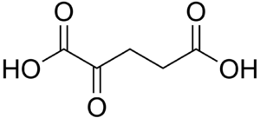

A) it will spontaneously decarboxylate

B) it is fully oxidized

C) it is a β-keto carboxylic acid

D) it contains at least one group more oxidized than an aldehyde

E) it contains at least one group more reduced than an alkane

21) The committed step of the Urea Cycle, shown below, is catalyzed by Carbamoyl Phosphate Synthetase. This reaction would be classified as what type?

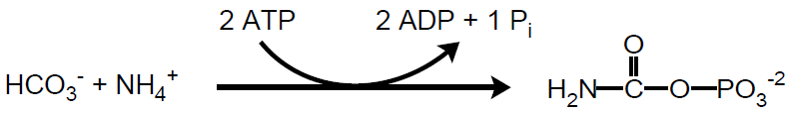

A) Transferase

B) Hydrolase

C) Lyase

D) Isomerase

E) Ligase

**Use the information provided below for the enzymes Glucokinase and Hexokinase to answer questions 22 - 23**

Reaction catalyzed: Glucose + ATP 🡪 Glucose-6-phosphate (G6P) + ADP

Glucokinase Hexokinase

Tissue distribution liver & b-cells most tissues

Km for glucose 10 mM 0.1 mM

Vmax High Low

Inhibited by G6P No Yes

22) You have a large, high starch meal and just afterwards your blood glucose level increases from a normal value of about 4 mM and peaks at around 10 mM. Which of the following statements describes the most likely activity levels of Glucokinase and/or Hexokinase given the information above?

A) Both enzymes will be maximally active

B) Hexokinase activity will increase after the meal

C) Glucokinase will be at half maximal velocity after the meal

D) Glucokinase will be at maximal velocity after the meal

E) Hexokinase maximal velocity will increase after the meal

23) Glucose-6-phosphate can bind to the active site of hexokinase and prevent further turnover by blocking the access of substrates. Depending on the concentration of this product, what would be the effect on enzyme kinetic properties?

A) The apparent Vmax would be expected to increase

B) The apparent Vmax would be expected to decrease

C) The apparent Km would be expected to decrease

D) The apparent Km would be expected to increase

E) The apparent Km would remain constant

**Use the following information to answer the questions 24 and 25**

The glycolytic enzyme, Triose phosphate isomerase, is considered a “perfect enzyme” and is able to catalyze the interconversion of glyceraldehyde-3-phosphate (GAP) and dihydroxyacetone phosphate (DHAP), shown below, at a rate approaching the diffusion limit. The equilibrium of the reaction favors the formation of DHAP (Keq= 0.05 as written left to right), however, it is GAP that is a substrate for the next step of glycolysis.

24) Which of the following statements properly describes triose phosphate isomerase’s action?

A) It will affect k1 and k-1 equally

B) It will shift Keq to favor formation of GAP

C) It will destabilize the transition state between GAP and DHAP

D) It will decrease the overall ΔG of the reaction

E) It will convert all GAP to DHAP

25) If typical intracellular concentrations of these metabolites are [DHAP] = 2 mM and [GAP] = 0.5 mM, what would be the ΔG’ of this reaction as written left to right inside the cell? Your calculated value is CLOSEST to:

(Note: G’ = Go’ + 1.4Log[products]/[reactants])

A) +1.82

B) +0.98

C) -1.82

D) -2.66

E) +2.66

26) The oxidation of an ingested candy bar and transfer of the energy to ATP for future use would be a complete example of what process?

A) digestion

B) respiration

C) anabolism

D) metabolism

E) absorption

27) Penicillinase is an enzyme present in some bacteria that can inactivate the antibiotic penicillin. Based on the Lineweaver Burk plot below, detetermine the Vmax and Km of penicillinase.

**Vmax** (nmol/min) **Km** (µM)

A) -0.2 1.5

B) 5 0.67

C) 0.67 5

D) 1.5 0.67

E) 1.5 -0.2

28) The enzyme acetyl-CoA carboxylase catalyzes the committed step in fatty acid synthesis:

Acetyl-CoA + CO2 + ATP 🡪 Malonyl-CoA + ADP + Pi

Which of the following vitamin coenzymes is most likely to participate in this reaction?

A) thiamine pyrophosphate

B) coenzyme A

C) tetrahydrofolate

D) cobalamin

E) biotin

29) You are seeing a 65 year old woman who recently had gastric bypass surgery and who has developed symptoms of fatigue and weakness which she attributed to increased stress in her life. She reported that she consumes moderate amounts of alcohol. Upon reviewing her blood panel, you inform her that she has developed anemia likely due to a deficiency in:

A) vitamin B5

B) vitamin B12

C) intrinsic factor

D) vitamin B3

E) adenine monophosphate

30) The enzyme phosphofructokinase 1 (PFK1) catalyzes the first committed step of glycolysis, conversion of fructose-6-phosphate to fructose-1,6-bisphosphate. Citrate is capable inhibiting PFK1 upon binding the enzyme at a site other than the active site. This is an example of:

A) negative cooperatively

B) product inhibition

C) allosteric regulation

D) the saturation effect

E) competitive inhibition

31) The metabolic process that produces cellular energy sources, molecular building blocks, and reducing equivalents is characterized by which of the following statements?

A) it is a constructive process

B) it is an oxidative process

C) it is cytosolic in location

D) it primarily consumes energy

E) it is predominantly unregulated

**Use the following case to answer questions 32**

A 65 year old male patient is in your office for an annual checkup. He is 6 feet 1 inch tall and weighs 180 lbs (82 kg). He generally consumes a daily diet of 350 g carbohydrates, 60 g fat, and 90 g protein and based on his reported physical activity, you determine that he will likely utilize energy at about 1.3 times his basal metabolic rate.

BMI = ((weight in pounds)*704) and **underweight: below 18.5**

(height in inches)2  **normal: 18.5-24.9**

**overweight: 25-29.9**

**obese: 30 & above**

|  |  |  |
| --- | --- | --- |
| **Age Range** | **BMR** | **BMR** |
| **(years)** | **(Kcal/d)** | **(kcal/d)** |
|  | **males** | **females** |
| **0 -3** | **60.9 x W - 54** | **61.0 x W - 51** |
| **3 - 10** | **22.7 x W + 495** | **22. x W + 499** |
| **10 - 18** | **17.5 x W + 651** | **12.2 x W + 746** |
| **18 - 30** | **15.3 x W + 676** | **14.7 x W + 496** |
| **30 - 60** | **11.6 x W + 879** | **8.7 x W + 829** |
| **> 60** | **13.5 x W + 487** | **10.5 x W + 596** |

32) Given that the BMR table uses weight in kilograms, which of the word pairs below accurately completes the following statement concerning this patient’s health and prognosis?

**The patient is currently ___I___, and will ___II___, given current diet and activity level.**

**I II**

A) underweight gain weight

B) normal weight maintain weight

C) overweight gain weight

D) overweight maintain weight

E) normal weight gain weight

END OF EXAMINATION - Tear off this sheet and save to check your answers.

* You may write in your answer to each question on this sheet. DO NOT make any other marks on this sheet. If there are any extraneous marks on this page it will be confiscated.
* Only the answer on the scantron is the official answer. **WE CANNOT USE THE ANSWERS ON THIS TEAR OFF SHEET TO DETERMINE YOUR GRADE.**

**Please remember to:**

* Write in the **letter of your form** in the area titled “Subject” on the exam scantron.
* **Return your examination** in the envelope providedto a proctor **before leaving the exam room**.

FORM: A

1. _____

2. _____

3. _____

4. _____

5. _____

6. _____

7. _____

8. _____

9. _____

10. _____

11. _____

12. _____

13. _____

14. _____

15. _____

16. _____

17. _____

18. _____

19. _____

20. _____

21. _____

22. _____

23. _____

24. _____

25. _____

26. _____

27. _____

28. _____

29. _____

30. _____

31. _____

32. _____