**Exam Procedures:**

**STEP 1 - NAME (*Print clearly*) _________________ ____________________________**

*(first) (last)*

**STEP 2 – Fill in your answer sheet, using a #2 scoring pencil, as follows:**

* Your Student PID Number (excluding “A”)
* Your last name and first name
* Course ID in “subject” …… **this is** **BMB 514 Exam #3**
* Date …… **10/22/12**
* Exam form in “period” …..**this is form A**
* By signing this coversheet for this exam, the student certifies that he/she has adhered to the policies of academic honesty in the performance of this exam.

_____________________________________

Signature

**STEP 3 - Read these instructions:**

* Make sure your exam has **64** questions.
* Read each question very carefully. Choose the single, best answer and mark this answer on your answer sheet. No points will be added for correct answers which appear on the exam page but not on the answer sheet.
* No electronic or computational devices are to be used. Cell phones must be off (not on vibrate) and stored with your bags/backpacks/other materials.
* The proctors have the authority/responsibility to assign any student a different seat at any time, without implication and without explanation, before or during the examination, as they deem necessary. Accomplish any relocation quietly and without discussion.
* We will not answer questions of clarification. However, if you think there is an error on your exam, summon an exam proctor.
* When you finish, place all exam materials (except the tear sheet) into the manila envelope. When you leave the exam room, please turn in your envelope to the proctors. Once you exit the auditorium, please leave the area. Hallway conversations disturb those still taking the exam.
* There will be answer keys to this exam posted on the course website by 5:00 p.m. the day of the exam. You may wish to copy your responses from your answer sheet onto the answer grid on the LAST page of this exam so that you can check your results. You can tear off the last page and take it with you.
* We will close the exam promptly at **10:00 a.m.** At the announcement of the examination end time, the examination and scantron and images (if provided as part of the examination) must immediately be placed into the manila envelope provided.

***STEP 4 – Wait until instructed to proceed with the exam!***

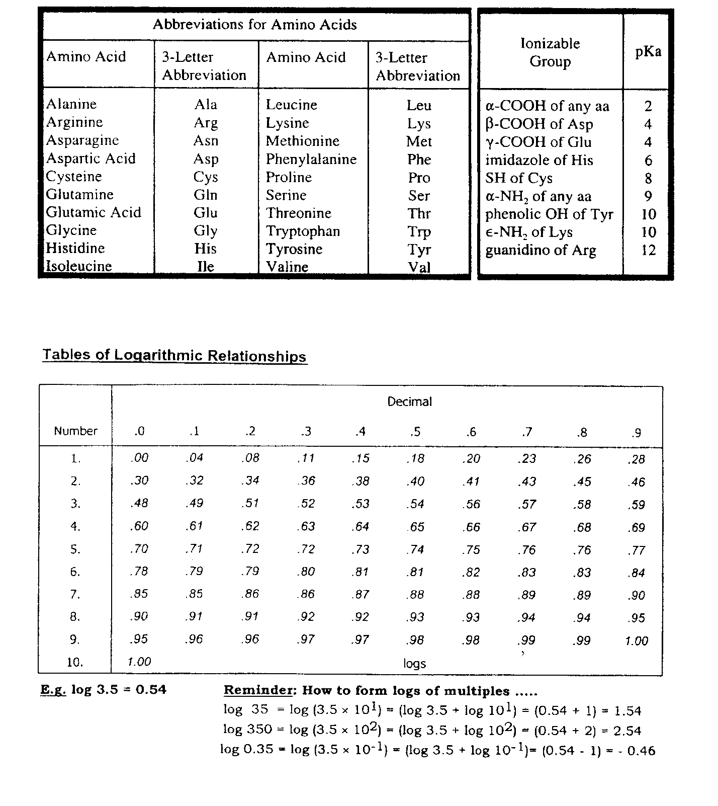

The following 6 questions deal with the patient description and date presented below:

A 52 year old man (5’8”, 175 lbs) entered the clinic suffering from extreme stomach pain and vomiting. He explains that over the last four years he has been on a strict ketogenic diet, averaging less than 20 grams of carbohydrates/day. He explains that he has lost approximately 170 pounds during this time. His diet strategy dictated that he obtain 80% of his calories from fat, 15% from protein, and 5% from carbohydrates. He admits that he rationalized that if eating as few as 20 gram/day was good, trying to eat 0 grams would be even better. Upon admission, he had the following lab data:

1. While reviewing the patient’s files, you spilled some caramel sauce on the lab report that made it impossible to discern the HCO3- value. Given your experience as a biochemist, you are not concerned and decide to calculate from the available information. Which of the following is closest to the value you calculate?
2. 11.3 mEq/L
3. 26.9 mEq/L
4. 15.2 mEq/L
5. 36.9 mEq/L
6. 23.9 mEq/L
7. Given the data, which of the following describes the current state of the patient?
8. Respiratory acidosis with partial metabolic compensation
9. Metabolic acidosis with partial respiratory compensation
10. Metabolic alkalosis with partial respiratory compensation
11. Respiratory alkalosis with partial metabolic compensation
12. Metabolic normalcy
13. Given the lab report data, which of the following would you expect to be true?
14. Fructose 2,6-bisphosphate levels will be abnormally high in the liver
15. The PDH complex will be phosphorylated and inactive
16. Glycogen synthase will be unphosphorylated and active
17. Hepatic mitochondrial malate dehydrogenase will favor the production of oxaloacetate
18. Hepatic glucokinase will be at Vmax
19. Which of the following enzymes will be fully active in the liver of the patient when he entered the clinic?
20. Malonyl CoA-ACP transferase
21. -ketoacyl-ACP synthase
22. Citrate synthase
23. HMG-CoA lyase
24. Branching enzyme
25. The patient admits that while trying to remove carbohydrates from his diet completely, he was eating nothing but sticks of butter and drinking gelatin-based protein shakes. He states that during these times he began feeling bloated, lost hair, had skin rashes, and felt very lethargic. You deduce that he was becoming protein deficient. Loss of which of the following amino acids might explain his symptoms?
26. Alanine
27. Proline
28. Serine
29. Glutamate
30. Isoleucine
31. Based on the available data, what is the most likely explanation for the patient’s pathology?
32. Nitrogen imbalance caused by decreased absorption of dietary proteins
33. Uric acid build up caused by hypoglycemia
34. Overproduction of fatty acids caused by electrolyte imbalance
35. Ketoacidosis caused by lack of carbohydrates in the patient’s diet
36. Acidosis caused by gastric ulcers
37. Which of the following statements correctly describes lecithin:cholesterol acyltransferase (LCAT)?
38. Is used by low density lipoproteins to modify cholesterol to make it more suitable to package into lipid membranes
39. High density lipoproteins use it to modify cholesterol so that it can be transported within the interior of lipoproteins
40. Is capable of attaching various types of acyl chains to cholesterol to make them more suitable for steroid synthesis
41. Is used by chylomicrons to bind cholesterol to lipid soluble vitamins and facilitate their transport
42. Transfers cholesterol to an acyl chain on a phospholipid to facilitate its packaging into low density lipoproteins.
43. Which of the following correctly describes the process of phospholipid degradation or a reason it is necessary?
44. There is a single phospholipase responsible for releasing the fatty acyl units from membrane bound phospholipids.
45. Fatty acyl units released from phospholipids are used in the synthesis of lipid soluble vitamins.
46. Arachidonic acid and Inositol 1,4,5-triphosphate (IP3) are both key signaling molecules released from phospholipids.
47. The breakdown of phospholipids only occurs in response to the cellular need for free fatty acyl chains.
48. Once a phospholipid loses one of its acyl chains it must be completely degraded and resynthesized *de novo*.
49. Which of the following is required for the transport of the carbon of mitochondrial acetyl CoA into the cytosol?
50. Isocitrate dehydrogenase
51. Glutamine transporter
52. Pyruvate kinase
53. Aspartate transporter
54. Citrate lyase
55. Patients suffering from chronic lymphocytic leukemia (CLL) are prone to thiamine deficiencies, most likely due to increased thiamine consumption by the long-lived leukocytes. These patients have increased circulating levels of pyruvate and lactate. Which of the following is the most likely explanation for these lab results?
56. The decreased thiamine will inhibit the transketolases of the pentose phosphate pathway, forcing more carbon towards glycolysis.
57. Decreased thiamine will inhibit pyruvate dehydrogenase complex activity leading to build up of substrates.
58. The loss of thiamine will inhibit acyl-CoA synthetase forcing the cells to be more dependent upon glycolysis for energy.
59. Loss of thiamine inhibits the transaminases necessary to convert pyruvate to alanine, thus leading to the observed build up.
60. The loss of thiamine will lead to an increased pyruvate kinase activity leading to a buildup of pyruvate, its product.
61. A decrease in activity of the enzyme UDP-glucose pyrophosphorylase might impact hepatocytes’ ability to perform which of the following tasks?
62. Glycogen breakdown and entry of fructose into glycolysis
63. Glycogen breakdown and entry of galactose into glycolysis
64. Glycogen synthesis and entry of galactose into glycolysis
65. Glycogen synthesis and entry of fructose into glycolysis
66. Glycogen synthesis and entry of sucrose into glycolysis

The next 2 questions deal with the following patient:

A 47 year old woman is admitted to the hospital with a suspicion of early stage breast cancer. Upon further testing, it was determined the patient has an 8-12 mm mass on her left breast and is immediately scheduled for a lumpectomy.

1. One course of treatment following the lumpectomy is regular doses of Tamoxifen, an estrogen receptor inhibitor. Tamoxifen has been demonstrated to become bioactivated to more active metabolites by an NADPH-dependent cytochrome P450 enzyme, Cyp2D6. Which of the following enzymes, if mutated, would impact the clinical effectiveness of tamoxifen in this patient?
2. Glucose 6-phosphate dehydrogenase
3. HMG-CoA Reductase
4. -ketoacyl-ACP reductase
5. Enol ACP reductase
6. Pryuvate kinase
7. Upon removing the primary tumor, histology demonstrates that the central portion of the tumor was hypoxic, one indicator of a more aggressive tumor. This decrease in available oxygen will most likely lead to which of the following metabolic outcomes in the tumor cells?
8. Decreased activity of lactate dehydrogenase
9. Increased turnover of the TCA cycle
10. Decrease in the potential across the inner mitochondrial membrane
11. Increased activity of -oxidation of free fatty acids
12. Increased translocation of malate from the mitochondrial matrix to the cytosol
13. Which of the following statements is correct regarding ketone body synthesis and cholesterol synthesis?
14. Both pathways synthesize 3-hydroxy-3-methylglutaryl CoA (HMG-CoA) in the cytosol of the cell.
15. Both pathways utilize the 5 carbon isopentenyl unit as an intermediate.
16. Both pathways require the activity of HMG-CoA lyase
17. Both pathways utilize acetoacetyl CoA
18. Both pathways are primarily regulated at the level of gene expression
19. Which of the following is a general feature of ALL transport lipoproteins?
20. A hydrophilic surface that is created by a phospholipid bilayer coating the hydrophobic interior.
21. At least one apolipoprotein that is responsible for directing the behavior and uptake of each particle.
22. A hydrophobic interior that contains free fatty acids and cholesterol.
23. Ability to donate fatty acyls to the tissues by activation of a lipase activity by apolipoprotein CII.
24. The ability to transport cholesterol from the tissues back to the liver
25. Which of the following would favor full activation of gluconeogenesis?
26. High levels of fatty acid oxidation
27. High cellular concentrations of ADP
28. High insulin levels
29. Low citrate levels
30. High fructose 2,6-bisphosphate
31. Which of the following pathways is correctly paired with one of its regulatory enzymes?
32. Glycogenesis: glycogen phosphorylase.
33. Cholesterol synthesis: HMG-CoA lyase.
34. β-oxidation of fatty acids: carnitine acyltransferase I (CAT I)
35. Glycolysis: phosphoglycerate kinase.
36. Fatty acid synthesis: enoyl-ACP reductase.
37. A patient with a deleterious mutation in the gene encoding cholesterol 7-α-hydroxylase is most likely to suffer from which of the following?
38. Increased absorption of dietary lipids.
39. Increased concentrations of cholic acid
40. Increased risk of gallstones.
41. Increased risk of fasting induced hypoglycemia
42. Increased risk of hyperchylomicronemia
43. A mutation in which of the following enzymes will negatively impact your ability to produce phospholipids, such as dipalmitoylphosphatidyl choline, which are necessary lung surfactants?
44. Phosphatidate cytidylyl transferase
45. HMG-CoA Reductase
46. Fatty acyl CoA dehydrogenase
47. carnitine acyltransferase I
48. Phosphatidate phosphatase
49. 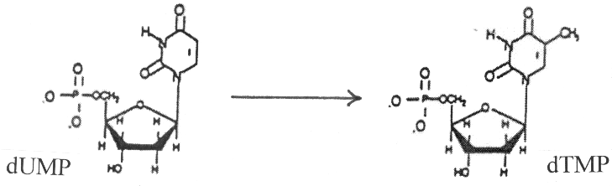Identify the direct donor of the one-carbon unit in the reaction shown below, catalyzed by thymidylate synthase.

A) methyl-cobalamin (CH3-B12)

B) N5, N10-methylene tetrahydrofolate (methylene THF)

C) N5-methyl tetrahydrofolate (methyl THF)

D) S-adenosylmethionine (SAM)

E) methotrexate

1. Identify the direct donor of the one-carbon units in the reaction shown below, catalyzed by phosphatidylethanolamine methyl transferase.
2. 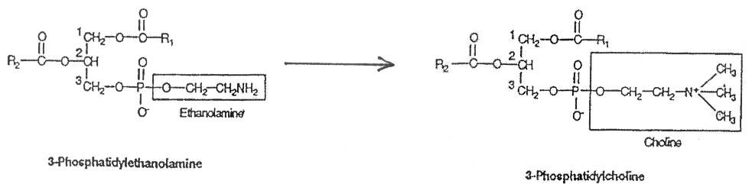methyl-cobalamin (CH3-B12)
3. N5, N10-methylene tetrahydrofolate (methylene THF)
4. N5-methyl tetrahydrofolate (methyl THF)
5. S-adenosylmethionine (SAM)
6. methotrexate
7. 5-Phosphoribosyl-1-pyrophosphate (PRPP) is a substrate for which of the following enzymes?
8. ribonucleotide reductase
9. thymidylate synthase (TS)
10. uridine kinase
11. carbamoyl phosphate synthetase-II (CPS-II)
12. hypoxanthine-guanine phosphoribosyl transferase (HGPRT)

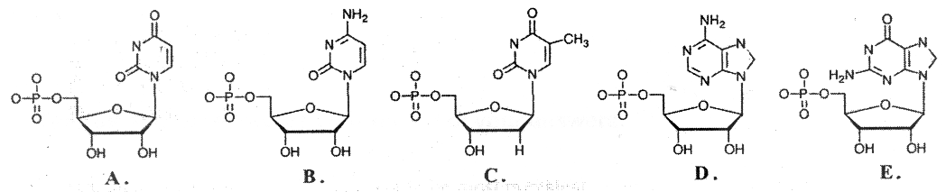**For Questions 23 - 25, choose from the nucleotides whose structures are shown below. Each nucleotide can be used more than once or not at all in these questions. You might find it helpful if you identify each compound by its name before attempting to answer the questions.**

1. Ribonucleotide reductase is required for the synthesis of which of the above nucleotides (A-E)?
2. Which of the above nucleotides (A - E) is the direct product of thymidylate synthase.

1. Phosphofructokinase-1 (PFK-1) is activated by high concentrations of one of the above nucleotides (A - E), which signals that the cell's energy stores are depleted. Identify this allosteric activator of PFK-1.
2. A 42-year-old male cancer patient undergoing radiation therapy (which kills lots of cells and leads to degradation of their intracellular contents) develops severe pain in his right big toe. Laboratory analyses indicate an elevated serum uric acid level and urate crystals in his urine. This patient's pain is caused by the overproduction of the end product of which of the following metabolic pathways?

A) Pyrimidine nucleotide catabolism

B) Ketone body synthesis

C) Pentose phosphate pathway

D) β-oxidation of fatty acids

E) Purine nucleotide catabolism

1. A one-year-old female patient is lethargic, weak, and anemic. Her height and weight are both low for her age. Her urine contains an elevated level of orotic acid. The administration of which of the following compounds is most likely to alleviate her symptoms?

A) Adenine

B) Guanine

C) Hypoxanthine

D) Thymidine

E) Uridine

1. Patients with gout arising from biochemical (rather than physiological) causes are sometimes treated with allopurinol. In cells from treated patients, allopurinol would cause an **increase** in which of the following metabolic events?

A) excretion of uric acid

B) *de novo* synthesis of purine nucleotides

C) salvage of hypoxanthine and guanine

D) synthesis of thymidine

E) ribonucleotide reductase activity

**The next three questions refer to the patient and data provided below.**

**Patient**: 55-year old, Caucasian, female

**Presenting complaint:**

● loss of energy; easily fatigues; dyspnea (difficult breathing) on climbing two flights of stairs

● weight loss of about eight pounds over the last six months

● although bowel movements were regular, she noticed that the stool was dark colored

● upon questioning, she remembers a few recent episodes of tingling (paresthesia) in her toes

**Review of history and systems:**

● About nine years ago, her family physician diagnosed her with anemia, which was treated with monthly “shots” (patient does not know contents of the “shots”).

● She has had no “shots” in the last year because her physician died at that time and she has not yet connected with another doctor.

**Physical examination:** Nothing unusual, except her skin appears pale (which her friends have also noticed).

**Complete Blood Count (CBC) results:** The relevant data are revealing and are shown below.

**Patient Normal**

White blood cells (103/μl) 4.1 4.5 – 10.5

Red blood cells (106/μl) 2.6 4.2 – 5.4 (for female)

Hematocrit (%) 28 37 – 47 (for female)

Hemoglobin (g/dl) 9.4 12 – 16 (for female)

Mean Corpuscular Volume (μm3) 108 80 – 96

Mean Corpuscular Hemoglobin (pg) 36 27 – 31

Mean Corpuscular Hemoglobin Concentration (g/dl) 33.6 33 – 37

Platelets (103/μl) 110 150 – 350

Reticulocytes (% of erythrocytes) 0.3 0.5 – 1.5

1. On the basis of the data presented above, which of the following would most accurately describe this patient’s medical conditions?
2. gouty hyperuricemia
3. iron deficiency microcytic anemia
4. Lesch-Nyhan syndrome
5. macrocytic anemia
6. glycogen storage disease
7. The paresthesia (e.g. tingling in her toes) suggests neurological problems due to abnormal membrane structure in the nervous system. You test your hypothesis by ordering a test for the patient's absorption of **X**, both in the presence and absence of **Y**.

**X Y**

A) vitamin B1 thiamine transketolase

B) vitamin B3 niacin nicotinamide

C) vitamin B12 cobalamin intrinsic factor

D) vitamin C ascorbate collagen

E) vitamin H biotin pyruvate carboxylase

1. Assuming that your hypothesis turned out to be correct, two other compounds would be beneficial if administered to the patient. These are:

A) DNA and RNA

B) folic acid and S-adenosylmethionine

C) ribose 5-phosphate and 5-phosphoribosyl pyrophosphate

D) bilirubin and uric acid

E) uric acid (keto form) and uric acid (enol form)

1. Proteins are effective buffers over a wide range of pHs because they usually contain:

A) a large number of amino acids

B) amino acid residues with different pKa values

C) amino-terminal and carboxyl-terminal residues that can donate or accept protons

D) peptide bonds that readily ionize, consuming H+ and OH- ions

E) a large number of hydrogen bonds in α-helices

1. The tertiary structure (three-dimensional structure) of a protein is determined by:
2. its amino acid sequence
3. the total charge on the molecule
4. its amino acid composition
5. the number of proline residues in the molecule
6. whether or not the protein is acidic

**Questions 34 -36 refer to the lab results shown below. Match each of the clinical descriptions with the lab result that seems most appropriate.**

**pCO2 [HCO3-]**

**pH mm Hg _ mM__**

normal range 7.35 – 7.45 35-45 22-26

A) 7.22 69 26

B) 7.50 29 22

C) 7.26 26 11

D) 7.33 68 34

E) 7.40 40 24

1. 26-year-old medical student with an acute anxiety attack and a respiratory rate of 26/min (normal range is 12-18 breaths/min). Because the condition is acute, not enough time for compensation.
2. Semi-comatose 27-year-old man with heroin overdose (respiration rate of 6 breaths/min with normal range 12-18 breaths/min). There has not been enough time for compensation).
3. 47-year-old female smoker with chronic bronchitis (because the condition is chronic, there has been opportunity for compensation).
4. The arterial blood of a patient yielded the following information:

pH = 7.1

Total CO2 content = 28 mM

Other useful information: (a) pKa = 6.1 for the bicarbonate - pCO2 blood buffer;

(b) solubility coefficient for CO2 at 37 oC = 0.03 mM/mm Hg

The pCO2 value for this sample of blood is closest to:

A) 28 mm Hg

B) 40 mm Hg

C) 56 mm Hg

D) 85 mm Hg

E) 100 mm Hg

1. Which of the following conditions causes hemoglobin to release oxygen more readily?

A) Increased production of 2,3-diphosphoglycerate (DPG)

B) Hyperventilation, leading to decreased levels of CO2 in the blood

C) Metabolic alkalosis

D) Replacement of the β-subunits of the hemoglobin tetramer with γ-subunits

[HbA consists of α2β2 subunits while HbF consists of α2γ2 subunits]

1. 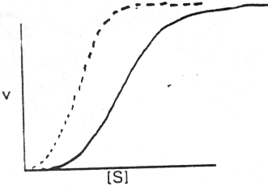In the graphs shown below, in which the initial rate of an enzyme-catalyzed reaction was plotted against the substrate concentration, the solid line represents data obtained in the absence of any drug while the dotted line represents data obtained in the presence of the drug X. Which of the following statements about this system is **TRUE**?

A) Drug X increases the maximal velocity of the enzyme.

B) Drug X acts as a positive effector of the enzyme.

C) Drug X acts as a negative effector of the enzyme.

D) Drug X has no effect on the enzyme.

E) The enzyme exhibits simple Michaelis-Menten kinetics in the absence of Drug X.

1. A patient is being treated with Orlistat (a pancreatic lipase inhibitor) for weight control. The absorption of which of the following molecules will be impacted in this patient while on Orlistat?
2. Vitamin K
3. Maltose
4. Short chain fatty acids
5. Vitamin B12
6. Alanine
7. Which of the following statements about protein metabolism is correct?
8. Essential amino acids are stored in the liver till needed for protein synthesis
9. Nitrogen is always excreted in balance with dietary protein intake
10. Proteins of a plant origin typically have the highest biological value
11. Endogenous protein degradation for bulk energy production is always pathological
12. Nitrogen containing compounds are all made using free ammonia
13. The acid environment of the stomach is important in protein digestion because it activates:
14. plasminogen
15. trypsinogen
16. pepsin
17. pepsinogen
18. enteropeptidase
19. If a patient has difficulty maintaining adequate nitrogen balance despite sufficient intake, and has excess oligopeptides in samples of stool, the most likely enzyme deficiency is:
20. Enteropeptidase
21. Trypsin
22. Pepsin
23. Elastase
24. Aminopeptidase
25. Which statement is true regarding normal protein turnover in a healthy patient?
26. All degraded protein is metabolized and the nitrogen excreted
27. All proteins last approximately the same in a cell before being degraded
28. Changes in metabolism can affect rates of protein turnover
29. Amino acids released are stored for future use
30. Energy is required for all protein turnover
31. In what unique way does muscle handle excess nitrogen?
32. it excretes it as alanine to the liver for use in gluconeogenesis
33. it excretes it as glutamine directly to the kidney for processing in the urea cycle
34. it recycles all nitrogen in protein synthesis
35. it excretes it as glutamate to the liver for processing in the urea cycle
36. it excretes it as α-ketoglutarate to the liver where it enters the TCA cycle

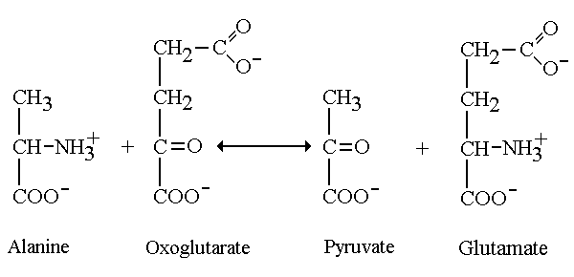

1. Which statement regarding the above reaction is correct?
2. oxaloacetate is a product of this reaction in the liver
3. serum levels of the enzyme that catalyzes this reaction is an indicator of tissue damage
4. hepatocyte levels of the enzyme that catalyzes this reaction is an indicator of liver damage
5. this reaction is catalyzed by an amino acid oxidase
6. the enzyme that catalyzes this reaction uses thiamine pyrophosphate as a cofactor
7. Which of the following correctly describes the activity or regulation of Glutamate Dehydrogenase *in the liver*?
8. its purpose is to fix nitrogen for amino acid synthesis
9. it oxidizes NADPH to NADP+ + H+
10. it is inhibited by high concentrations of ATP or GTP
11. free ammonia is excreted directly into the urine
12. the oxidation reaction produces H2O2 as a by product
13. Which product of the urea cycle can be reconverted to a substrate of the urea cycle?
14. aspartate
15. glutamate
16. fumarate
17. carbamoyl phosphate
18. malate

For questions 49-51 choose one of the following:

**A. thiamine**

**B. cobalamin**

**C. riboflavin**

**D. biotin**

**E. pyridoxine**

1. Which of the vitamins listed above is a co-factor of transaminases?
2. A deficiency in which of the vitamins listed above would result in glossitis of the tongue, chapping and breaking of skin around the mouth, and a scaly dermatitis?
3. Which of the vitamins listed above is required for both odd chain length fatty acid metabolism and some branched chain amino acid metabolism?

Use the following case to answer the next three questions.

A person has consumed enough alcohol to be right at the legal driving limit of 0.08% blood alcohol content. (18 mM) Determine the kinetic parameters of this person’s liver alcohol dehydrogenase enzyme from the graph below and calculate the rate of alcohol metabolism in this individual.

Given: v = Vmax * [S]/([S] + Km)

1. The rate of alcohol metabolism in this individual is closest to:
2. 3.1 µM sec-1
3. 0.67 µmol sec-1
4. 3.1 µmol sec-1
5. 0.33 µmol sec-1
6. 0.67 µM sec-1
7. At this alcohol concentration, gluconeogenesis is about 50% inhibited. Which of the following molecules accumulates and is responsible for this inhibition?
8. pyruvate
9. NADH
10. inorganic phosphate
11. ADP
12. lactate
13. The addition of 4-methyl pyrazole (a non-competitive inhibitor) would have what effect on the apparent kinetic parameters of this enzyme?

**(apparent) Vmax (apparent) Km**

1. lower higher
2. higher no change
3. no change higher
4. lower no change
5. no change lower
6. A newborn is diagnosed with hereditary hyperammonemia. It is found that she has high levels of glutamine and creatinine in her urine but undetectable levels of citrulline. Which enzyme is likely deficient in this baby?
7. carbamoyl phosphate synthetase I
8. ornithine transcarbamolylase
9. arginiosuccinate synthetase
10. arginiosuccinate lyase
11. arginase
12. Which of the following tissues can only use glucose as a fuel source?
13. brain
14. kidney
15. red blood cells
16. heart
17. muscle
18. A mother brings in her 9 month old daughter to your office because she is worried about her development and protruding abdomen. The mother is pregnant again and she has been feeding the baby a cereal-based formula on demand since she was weaned at 5 months of age. She informs you that this is the traditional practice in her home nation from which she has recently immigrated. You suspect that this baby is developing what condition?
19. Kwashiorkor
20. VonGierke’s Disease
21. Marasmus
22. Phenylketonuria
23. Beri Beri
24. How do hormones effectively regulate metabolic pathways?
25. they are made in large quantities
26. they use second messengers and biological amplification
27. insulin always activates catabolic pathways
28. glucagon always inhibits catabolic pathways
29. insulin and glucagon are never present together
30. Most digestive enzymes are activated from their zymogen forms directly by:
31. pepsin
32. enteropeptidase
33. trypsin
34. chymotrypsin
35. elastase
36. The enzymes capable of attaching free ammonia to another molecule (fixing nitrogen) are:
37. glutamate dehydrogenase, amino acid oxidase, glutaminase
38. glutamine synthetase, amino acid oxidase, glutamate dehydrogenase
39. glutamate dehydrogenase, glutamine synthetase, aminotransferase
40. carbamoyl phosphate synthetase I, glutaminase, glutamate dehydrogenase
41. glutamate dehydrogenase, carbamoyl phosphate synthetase I, glutamine synthetase
42. Muscle is considered a “selfish” tissue because muscle cells:
43. will only release glucose for use by other muscle cells
44. excrete alanine instead of glutamine
45. store less glycogen than the liver
46. do not express glucose 6-phosphatase
47. will not use ketone bodies for energy
48. Insulin is an indicator of the fed state and typically results in ____I____of target enzymes to ____II___ them.

**I** **II**

1. dephosphorylation activate
2. dephosphorylation inactivate
3. phosphorylation activate
4. phosphorylation inactivate
5. autophosphorylation compartmentalize
6. A person with type I diabetes would have which of the following metabolic features compared to a person starved for five weeks?
7. a larger insulin: glucagon ratio
8. higher levels of circulating ketone bodies
9. equivalent circulating glucose levels
10. brain would be using more ketone bodies for fuel
11. red blood cells would begin using ketone bodies for fuel
12. Metabolic reactions with a positive ΔGº’ can proceed in cells due to:
13. a lowering of the standard state free energy
14. efficient removal of the product
15. enzymes that make these reactions thermodynamically favorable
16. coupling them to the synthesis of ATP
17. the inability of enzymatic reactions to go “backwards”

END OF EXAMINATION - Tear off this sheet and save to check your answers.

* You may write in your answer to each question on this sheet. DO NOT make any other marks on this sheet. If there are any extraneous marks on this page it will be confiscated.
* Only the answer on the scantron is the official answer. **WE CANNOT USE THE ANSWERS ON THIS TEAR OFF SHEET TO DETERMINE YOUR GRADE.**

**Please remember to:**

* Write in the **letter of your form** in the area titled “Period” on the exam scantron.
* **Return your examination** in the envelope providedto a proctor **before leaving the exam room**.

**FORM: A**

1. _____

2. _____

3. _____

4. _____

5. _____

6. _____

7. _____

8. _____

9. _____

10. _____

11. _____

12. _____

13. _____

14. _____

15. _____

16. _____

17. _____

18. _____

19. _____

20. _____

21. _____

22. _____

23. _____

24. _____

25. _____

26. _____

27. _____

28. _____

29. _____

30. _____

31. _____

32. _____

33. _____

34. _____

35. _____

36. _____

37. _____

38. _____

39. _____

40. _____

41. _____

42. _____

43. _____

44. _____

45. _____

46. _____

47. _____

48. _____

49. _____

50. _____

51. _____

52. _____

53. _____

54. _____

55. _____

56. _____

57. _____

58. _____

59. _____

60. _____

61. _____

62. _____

63. _____

64. _____