**Exam Procedures:**

**STEP 1 - NAME (*Print clearly*) _________________ ____________________________**

*(first) (last)*

**STEP 2 – Fill in your answer sheet, using a #2 scoring pencil, as follows:**

* Your Student PID Number (excluding “A”)
* Your last name and first name
* Course ID in “subject” …… **this is** **BMB 526 Exam #1**
* Date …… **11/5/12**
* Exam form in “period” …..**this is form A**
* By signing this coversheet for this exam, the student certifies that he/she has adhered to the policies of academic honesty in the performance of this exam.

_____________________________________

Signature

**STEP 3 - Read these instructions:**

* Make sure your exam has **34** questions.
* Read each question very carefully. Choose the single, best answer and mark this answer on your answer sheet. No points will be added for correct answers which appear on the exam page but not on the answer sheet.
* No electronic or computational devices are to be used. Cell phones must be off (not on vibrate) and stored with your bags/backpacks/other materials.
* The proctors have the authority/responsibility to assign any student a different seat at any time, without implication and without explanation, before or during the examination, as they deem necessary. Accomplish any relocation quietly and without discussion.
* We will not answer questions of clarification. However, if you think there is an error on your exam, summon an exam proctor.
* When you finish, place all exam materials (except the tear sheet) into the manila envelope. When you leave the exam room, please turn in your envelope to the proctors. Once you exit the auditorium, please leave the area. Hallway conversations disturb those still taking the exam.
* There will be answer keys to this exam posted on the course website by 5:00 p.m. the day of the exam. You may wish to copy your responses from your answer sheet onto the answer grid on the LAST page of this exam so that you can check your results. You can tear off the last page and take it with you.
* We will close the exam promptly at **9:10 a.m.** At the announcement of the examination end time, the examination and scantron and images (if provided as part of the examination) must immediately be placed into the manila envelope provided.

***STEP 4 – Wait until instructed to proceed with the exam!***

# INFORMATION THAT MAY BE USEFUL FOR THE EXAM

GeneticCodeTable.12A.tif

WobbleRules.12A.tif

**INFORMATION ON COMPONENTS OF RIBOSOMES**

I. Prokaryotes (e.g. *E. coli*)

RIBOSOME (70S)

Large Subunit (50S) --- 5S and 23S rRNAs + many proteins

Small Subunit (30S) --- 16S rRNA + many proteins

II. Eukaryotes (e.g. human)

RIBOSOME (80S)

Large Subunit (60S) --- 5S, 5.8S, and 28S rRNAs + many proteins

Small Subunit (40S) --- 18S rRNA + many proteins

1. The following terms refer to human nuclear material. Arrange them in order of **increasing** size and structural complexity:

A. codons, exons, genes, chromosomes, genome

B. exons, genes, chromosomes, genome, codons

C. genes, chromosomes, genome, codons, exons

D. chromosomes, genome, codons, exons, genes

E. genome, chromosomes, genes, exons, codons

acrocentric.12B.tif2. The schematic diagram below depicts a condensed chromosome after replication. To which structure does the arrow point?

A. a satellite

B. a telomere

C. a p-arm

D. a centromere

E. a genome

3. During meiosis I, the parent and daughter cells have which of the following chromosome composition?

**parent daughter**

A. haploid haploid

B. haploid diploid

C. diploid haploid

D. diploid diploid

E. tetraploid tetraploid

4. Which of the following intermolecular events does **NOT** depend on proper base pairing of nucleic acids?

A. delivery of tRNAs to the P site of a ribosome

B. recognition of 5’-splice sites

C. binding of prokaryotic ribosomes near the translation initiation site

D. synthesis of primers for lagging strand replication

E. recognition of the signal sequence during synthesis of secreted proteins

5. Which of the following statements **correctly** describes the enzyme telomerase?

A. Telomerase extends the 3’ ends of the newly synthesized DNA strands.

B. Telomerase is a topoisomerase that segregates the replicated DNA of prokaryotes.

C. Telomerase has reverse transcriptase activity.

D. Telomerase carries its own DNA template.

E. Telomerase requires an RNA primer for extension.

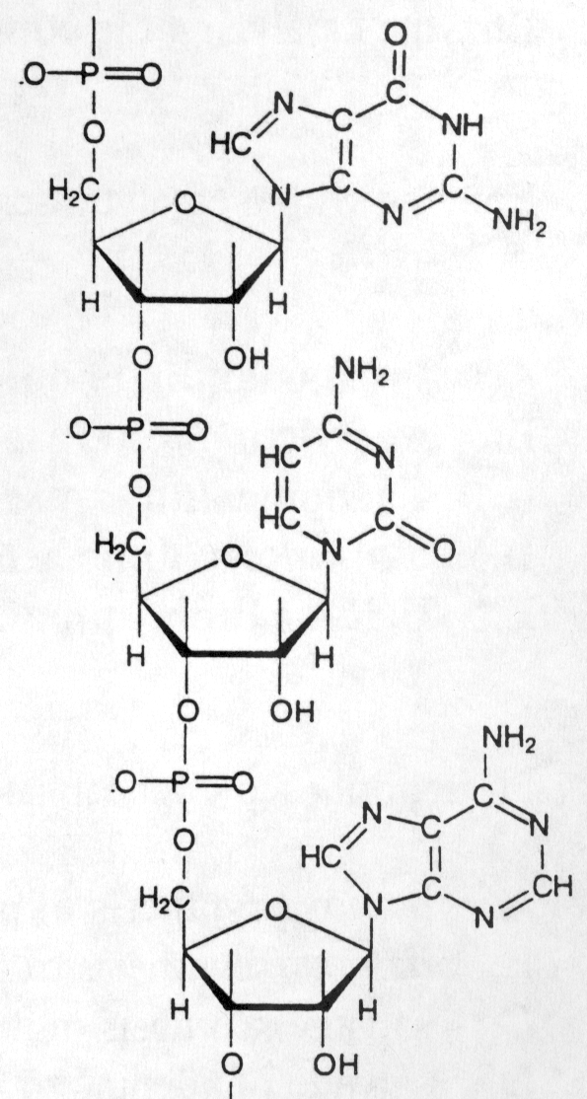6. The segment of a molecule (whose structure is shown to the right) depicts a codon (5' --->3', top to bottom) for an amino acid. Identify that amino acid. If a transition mutation occurred at position 2 of the same codon, what would the mutant codon code for?

**wild-type mutant**

A. cysteine (Cys) alanine (Ala)

B. alanine (Ala) glycine (Gly)

C. alanine (Ala) valine (Val)

D. cysteine (Cys) glycine (Gly)

E. threonine (Thr) valine (Val)

7. Which of the arrows in the diagram below best represents the position and direction of **leading strand** DNA synthesis? The vertical bars at the center of the diagram depict the replication origin.



8. Which of the following enzymes is the major processive enzyme in leading strand synthesis during eukaryotic DNA replication?

A. DNA polymerase α(alpha)

B. DNA polymerase β (beta)

C. RNA polymerase γ (gamma)

D. DNA polymerase ε (epsilon)

E. telomerase

9. Some patients with familial hypercholesterolemia produce a truncated form of the LDL receptor which lacks three of the five domains of the protein, causing it to be retained in the endoplasmic reticulum. Analysis of the mutant gene indicates that the sequence is normal up to the point where the protein is terminated. The genetic change that produces the mutant LDL receptor in these cases is most likely a/an

A. silent mutation

B. missense mutation

C. nonsense mutation

D. insertion

E. gene duplication

10. Transcriptional initation of the blood clotting cascade Factor VIII gene will depend upon which of the following:

A. ribosomal recognition sequence

B. primase

C. sigma factor

D. TFIID

E. RNA polymerase III

11. Not all mutations inside the open reading frame of a gene encoding a protein change the amino acid sequence of the protein because:

A. tRNAs carrying different amino acids can recognize the same codon

B. some codons specify more than one amino acid

C. two different codons can specify the same amino acid

D. some codons are skipped during translation

E. some codons consist of more than three nucleotides

12. Eukaryotic protein synthesis:

A. proceeds in a 5’🡪 3’ direction

B. is coupled to transcription

C. always begins with a formyl-methionine

D. utilizes energy stored in the aminoacyl-tRNA

E. terminates at the sequence 5’-AAUAAA-3’

13. Eukaryotic mRNAs contain:

A. formyl-methionine

B. multiple open reading frames

C. 7-methylguanosine

D. sequence specific ribosomal binding sites

E. deoxyadenosine

14. A recombinant gene was introduced into a mouse by a viral vector and a week later, assays for the new protein product were negative. Further, levels of the mRNA encoding the new protein product were below detection in most mice tested. What is the most likely reason for this observed phenomenon?

A. siRNA targeting and degradation of the new protein product

B. siRNA targeting and degradation of the mRNA from the recombinant gene

C. miRNA targeting and silencing of the recombinant promoter

D. miRNA targeting and degradation of the new protein product

15. Which of the following plays a key role in RNA editing?

A. mRNA

B. rRNA

C. tRNA

D. gRNA

E. snRNA

16. The most likely consequence of a mutation present at the location indicated by the arrow in the above hnRNA schematic would be:

A. none, this region of the RNA has no function

B. aberrant splicing of the RNA

C. the mRNA would be improperly capped

D. the mRNA would be unstable and prone to degradation

E. an altered response to regulatory factors

17. Protein components of the ribosome would need what targeting signals in order to be properly assembled and ready to function?

A. nuclear localization signal only

B. nuclear localization signal and lysosomal targeting signal

C. nuclear export signal only

D. nuclear export signal and signal sequence

E. nuclear localization signal and nuclear export signal

18. The Aquafish, a genetically modified salmon, expresses its recombinant growth hormone constitutively whereas the wild type farm salmon only expresses its growth factor gene at certain temperatures. What structural component of the growth hormone gene would be recognized by what protein to facilitate this specific expression profile in the wild type, farm salmon?

A. Promoter responsive element bound by a specific transcription factor

B. TATA box element bound by TFIID

C. Initiator element bound by RNAP-II

D. -35 box element bound by an alternative sigma factor

E. Operator element bound by an activator protein

19. Your patient comes in with a stuffy nose, red puffy throat, and general malaise. You deduce that he has a viral infection (a cold), and is suffering mostly from his own inflammatory response to the virus. What signaling pathway most likely resulted in the activation of those inflammatory genes?

A. Steroid hormone receptor pathway

B. Sterol responsive element pathway

C. NF-κB/Iκ-B pathway

D. heat shock pathway

E. DNA methylation pathway

20. A healthy woman is in her 9th month of pregnancy with a healthy, normal son. What is the imprinted pattern (maternal or paternal) of this boy’s two copies of chromosome 15 in his developing muscle and single copy in his developing sperm?

**Muscle Sperm**

A. both maternal maternal

B. one maternal, one paternal maternal

C. both paternal paternal

D. one maternal, one paternal paternal

E. both maternal paternal

21. A patient presents with α-thalessemia. Below is the mRNA transcribed from the patient’s α-globin gene. What is the most likely result in this individual?

Note: The ellipse (…) represents a continuation of the RNA beyond the sequence you are given.

- AGAGAGAACCCACCAUGGTGCTGTCT…-3’ Normal

5’ CAP

- AGAGAGAACCCACCAU**A**GTGCTGTCT…-3’ Patient

5’ CAP

A. defective transcription initiation

B. normal protein, this is a silent mutation

C. defective translation initiation

D. shorter protein, this is a nonsense mutation

E. Glycine 🡪 Serine mutation in the protein

22. Which of the following tRNAs would match both of the glutamine codons, but no others?



CUG

UUG

IUG

GUC

GUU

23. A 10-year-old Caucasian girl is brought in by her parents for evaluation of a skin disorder. The child has many freckles on her face, arms, and legs. The parents were told by previous physicians that she suffers from Xeroderma pigmentosum and that they should limit her exposure to sun light. What is the most likely etiology of this disorder?

A. deficient DNA replication

B. impaired DNA repair by nucleotide excision

C. defective RNA transcription from TATA-less promoter

D. impaired ribosomal protein translation

E. impaired DNA repair by photoreactivation

24. The diagram below schematically describes the coupling of transcription and translation in *E. coli.* Which of the following labels in this figure is CORRECT?



A. Coding strand of the DNA

B. Capped end of the mRNA

C. 80S ribosome complex

D. Formyl methionine of polypeptide

E. Direction of ribosome movement

25. Identify the direct donor of the methyl group in the reaction shown below, catalyzed by DNA methyltransferase 1 (DNMT1). The 5'-CpG-3' indicates that the substrate cytosine lies in a CpG island.

cytMecyt.12A.tif

A. methyl-cobalamin (CH3-B12)

B. N5, N10-methylene tetrahydrofolate (methylene THF)

C. N5-methyl tetrahydrofolate (methyl THF)

D. S-adenosylmethionine (SAM)

E. methotrexate

26. BRCA1 and BRCA2 are two key human genes that participate in recombination repair. Women with defects in either BRCA1 or BRCA2 have a >80% chance of developing breast cancer. A portion of the sequence of normal BRCA1 is given below. In one of the families studied, a transversion mutation had occurred within the BRCA1 gene at the position shown by the asterisk. What was the information effect of this mutation?



A. frameshift mutation

B. missense mutation

C. nonsense mutation

D. silent mutation

E. not enough information to tell

27. The DNA sequence of the BRCA1 gene that is recognized by the estrogen-estrogen receptor complex is most likely to be:

A. an estrogen responsive element

B. an iron responsive element

C. a histone acetyl transferase

D. a CAP (catabolite gene activator protein)-binding site

E. an operator

**Questions 28 and 29 refer to two patients in a Case Study, designated as Case A.**

28. A 2-day-old boy exhibits extreme lethargy and hyperventilation. Complete blood count (CBC) report documented megaloblastic anemia (low hematocrit, low RBC count, low plasma hemoglobin, and elevated mean corpuscular volume). The hyperventilation most likely reflected compensation for metabolic acidosis and this was consistent with urine analysis, which revealed orotic aciduria. Genetic analysis revealed that both of his alleles for orotate phosphoribosyl transferase (OPRT) had the same mutation. Of the following, what is the most likely class of this mutant allele and its expected inheritance pattern?

A. gain of function mutation; dominant inheritance pattern

B. gain of function mutation; recessive inheritance pattern

C. loss of function mutation; dominant inheritance pattern

D. loss of function mutation; recessive inheritance pattern

29. A second patient in this same Case Study (Case A), a 7-month-old girl, was also diagnosed with orotic aciduria. However, both of the alleles of her OPRT gene were normal. In her case, both of the alleles of orotidine 5'-phosphate decarboxylase, which catalyzes the step subsequent to OPRT in the pyrimidine biosynthesis pathway, were defective (in fact, both alleles carried the same mutation). In comparing the cause of orotic aciduria of the 7-month-old girl with that described for the 2-day-old boy, we have an example of:

A. syntenic genes

B. homologous recombination

C. locus heterogeneity

D. haplo-insufficiency

E. phenocopies

**Questions 30-34 refer to Case B described below.**

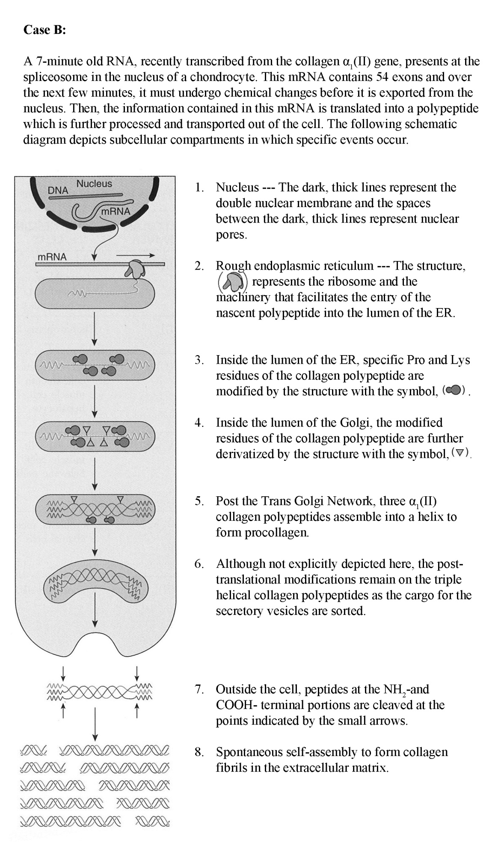

30. In the nucleus of the chondrocyte (location 1), which of the following enzymes was directly responsible for producing the primary transcript (the 7-minute old RNA) from the collagen α1(II) gene?

A) *E. coli* RNA polymerase

B) RNA polymerase I

C) RNA polymerase II

D) RNA polymerase III

E) reverse transcriptase

31. In splicing the primary transcript to form the functional RNA, which of the following components are used directly in the spliceosome?

A) sigma factor

B) TFII-D (the TATA-binding protein)

C) U1 small nuclear ribonucleoprotein complex (U1 snRNP)

D) 16 S rRNA

E) telomerase

32. Translation of the mRNA encoding the collagen polypeptide takes place at rough endoplasmic reticulum (location 2). Knowing where collagen polypeptides must ultimately end up, you would predict which of the following features for the first 20 amino acids of the just-translated collagen polypeptide?

A) The sequence will form an amphipathic helix.

B) The sequence will contain many hydrophobic residues.

C) The sequence will contain many arginine and lysine residues.

D) The sequence will contain leucine residues with requisite spacing.

E) The sequence will contain sacchride residues in place of amino acids.

33. Which of the following enzymes is required for the chemical modification of specific Pro and Lys residues of the collagen polypeptide in the lumen of the endoplasmic recticulum (location 3)?

A) lysyl oxidase

B) peptidyl transferase

C) prolyl hydroxylase

D) procollagen peptidase

E) signal peptidase

34. In the Golgi (location 4), the collagen polypeptide undergoes further post-translational modification on those Pro and Lys residues that had been previously modified in the lumen of the endoplasmic reticulum. Which of the following classes of enzymes is required for the Golgi modifications?

A) lysosomal hydrolases

B) ubiquitin-dependent proteases

C) vitamin C-dependent hydroxylases

D) glycosyl transferases

E) peptidyl transferase

END OF EXAMINATION Tear off this sheet and save to check your answers.

• You may write in your answer to each question on this sheet. DO NOT make any other marks on this sheet. If there are extraneous marks on this page, it will be confiscated.

• Only the answer on the scantron is the official answer. **We cannot use the answers on this tear off sheet to determine your grade.**

**Please remember to:**

• Write in the **LETTER** corresponding to the form of the exam in the area titled, "Period" on the exam scantron.

• **Return your examination**  in the envelope provided to a proctor **before leaving the exam room.**

**FORM: A**

1. _____ 11. _____ 21. _____ 31. _____

2. _____ 12. _____ 22. _____ 32. _____

3. _____ 13. _____ 23. _____ 33. _____

4. _____ 14. _____ 24. _____ 34. _____

5. _____ 15. _____ 25. _____

6. _____ 16. _____ 26. _____

7. _____ 17. _____ 27. _____

8. _____ 18. _____ 28. _____

9. _____ 19. _____ 29. _____

10._____ 20. _____ 30. _____