Exam Procedures:

STEP 1 - NAME (Print clearly) _________________ ____________________________
(first) (last)

STEP 2 – Fill in your answer sheet, using a #2 scoring pencil, as follows:

- Your Student PID Number (excluding “A”)
- Your last name and first name
- Course ID in “subject” …… this is BMB 526 Exam #3
- Date …… 12/13/12
- Exam form in “period” …..this is form A
- By signing this coversheet for this exam, the student certifies that he/she has adhered to the policies of academic honesty in the performance of this exam.

_____________________________________
Signature

STEP 3 - Read these instructions:

- Make sure your exam has 60 questions.
- Read each question very carefully. Choose the single, best answer and mark this answer on your answer sheet. No points will be added for correct answers which appear on the exam page but not on the answer sheet.
- No personal electronic or computational devices are to be used. Cell phones must be off (not on vibrate) and stored with your bags/backpacks/other materials.
- The proctors have the authority/responsibility to assign any student a different seat at any time, without implication and without explanation, before or during the examination, as they deem necessary. Accomplish any relocation quietly and without discussion.
- We will not answer questions of clarification. However, if you think there is an error on your exam, summon an exam proctor.
- When you finish, place all exam materials (except the tear sheet) into the manila envelope. When you leave the exam room, please turn in your envelope to the proctors. Once you exit the auditorium, please leave the area. Hallway conversations disturb those still taking the exam.
- There will be answer keys to this exam posted on the course website by 5:00 p.m. the day of the exam. You may wish to copy your responses from your answer sheet onto the answer grid on the LAST page of this exam so that you can check your results. You can tear off the last page and take it with you.
- We will close the exam promptly at 11:00 a.m. At the announcement of the examination end time, the examination and scantron and images (if provided as part of the examination) must immediately be placed into the manila envelope provided.

STEP 4 – Wait until instructed to proceed with the exam!

INFORMATION THAT MAY BE USEFUL FOR THE EXAM

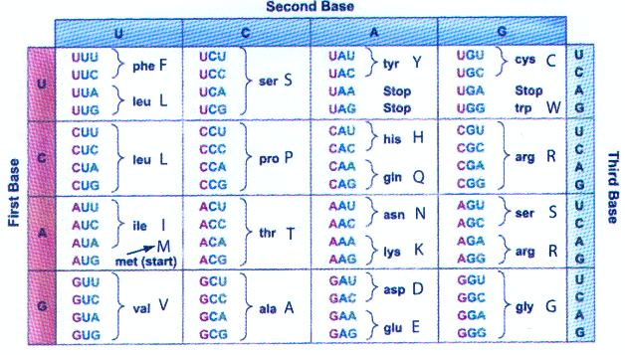

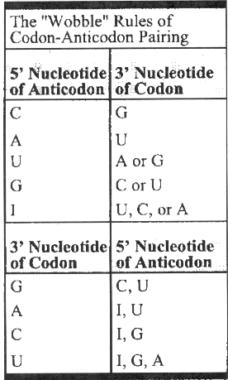
INFORMATION ON COMPONENTS OF RIBOSOMES

I. Prokaryotes (e.g. E. coli)

RIBOSOME (70S)

Large Subunit (50S) --- 5S and 23S rRNAs + many proteins
Small Subunit (30S) --- 16S rRNA + many proteins

II. Eukaryotes (e.g. human)

RIBOSOME (80S)

Large Subunit (60S) --- 5S, 5.8S, and 28S rRNAs + many proteins
Small Subunit (40S) --- 18S rRNA + many proteins

1. Dr. Smith has created a mouse strain that exhibits a greatly increased risk for liver cancer. Dr. Smith identified a candidate gene (gene XYZ) that has a heterozygous mutation in this mouse strain that is not present in his other strains of mice. After further research, Dr. Smith has concluded that gene XYZ is a tumor suppressor gene. Which of the following findings would support his conclusion?

A. Gene XYZ is involved in the process of signal transduction.
B. The heterozygous mutation inhibits gene XYZ from being appropriately inactivated.
C. Apoptosis is decreased in liver cells containing homozygous mutation in gene XYZ.
D. Sporadic mutations in gene XYZ in liver cells also increase the risk for liver cancer.

2. Which of the following statements about the two hit hypothesis of cancer development is TRUE?

A. If genetic testing of a retinoblastoma tumor identifies a point mutation in the RB1 gene, then this point mutation must have been inherited because point mutations cannot be somatic.
B. Loss of heterozygosity is a type of somatic mutation that can only lead to the occurrence of a hereditary cancer.
C. Hereditary cancers often result from two mutations (one mutation in each copy of a gene); one mutation is inherited and the other is somatic.
D. Hereditary cancer genes that follow the two hit hypothesis are inherited in an autosomal recessive manner.

3. Which of the following patients would be at the lowest risk for carrying a mutation in BRCA1 or BRCA2?

A. A 25 year old man whose mother was diagnosed with ovarian cancer at the age of 47.
B. A 25 year old woman whose father was diagnosed with breast cancer in his 50s.
C. A 25 year old woman whose sister had bilateral breast cancer in her 50s.
D. A 25 year old woman whose mother was diagnosed with breast cancer at the age of 68.

4. Johnny is studying hereditary cancers in school. His teacher said that most cancers are sporadic. She also said that people who have a hereditary cancer syndrome have a much higher risk for cancer than people who don’t have a hereditary cancer syndrome. Johnny is confused by these two statements. He believes that if the risk is so high with hereditary cancer syndromes, then most cancers should be due to a hereditary syndrome. Which of the following statements would most help Johnny to understand why hereditary cancer account for the small proportion of cancers?

A. Most of the genes associated with hereditary cancers have not yet been discovered.
B. Hereditary cancer syndrome are very rare, therefore while the cancer risk with these conditions are quite high, the percentage of individuals with these is relatively low.
C. Individuals who have a hereditary cancer syndrome are at a very high risk for a specific set of cancers (such as breast and ovarian cancer with BRCA1) but they won’t develop a cancer that can be related to an environmental exposure.
D. Johnny’s teacher is incorrect, hereditary cancer account for a larger percentage of all total cancers than sporadic cancers.

5. Which of the following screening or diagnostic methods is MOST useful in determining the risk for or diagnosing an open neural tube defect?

A. First trimester serum screening
B. Second trimester serum screening
C. Cell free DNA analysis
D. Chorionic villus sampling

6. Which of the following statements about maternal age is FALSE?

A. As a woman gets older, her risk for having a child with Down syndrome increases.
B. As a woman gets older, her risk for having a child with a trisomy for any autosomal chromosome increases.
C. Advanced maternal age as a screening tool for Down syndrome has high specificity and sensitivity.
D. A woman’s age is used as part of first trimester serum screening in determining the risk of having a baby with Down syndrome and trisomy 18.

7. Ashley has an appointment to discuss her family history. Recently, her father was diagnosed with Huntington disease and genetic testing showed that he has 51 CAG repeats in the huntingtin gene confirming the diagnosis. In addition, her mother was just recently diagnosed with ovarian cancer and found to have a mutation in BRCA1. After discussing both Huntington disease and hereditary breast/ovarian cancer, Ashley decides that she wishes to have genetic testing for the familial BRCA1 mutation but she does NOT want testing for Huntington disease. Which of the following statements by Ashley would best explain her decision?

A. “I want to test only for the condition that has 100% penetrance”
B. “I want to test for the condition that has specific medical recommendations that will allow me to avoid developing what my parent has.”
C. “I understand that there is no treatment, but I want to test for this condition to find out whether I could pass this on to my children.”
D. “I don’t want to be tested for Huntington disease because I could develop symptoms whether I have the mutation or not.”

8. A woman brings her 15 year old son to you. She asks that you perform a genetic test on her son. You learn that her husband died many years ago. Before her husband’s death, he had rectal bleeding. Pathology and colonoscopy reports identified that he had “thousands of adenomatous polyps” and “a sigmoid colon cancer arising from a polyp.” Testing of the APC gene was performed and her husband was found to have a mutation. You decide the best option is to:

A. test the 15 year old for the APC familial mutation because his medical management will depend on the results of this testing.
B. test the 15 year old for the APC familial mutation. Regardless of his APC testing results, recommend regular colonoscopy screening for the 15 year old because adenomatous polyps are not associated with APC gene mutations.
C. not test the 15 year old for the APC familial mutation because his medical management would be unaffected by the results of the test.
D. not test the 15 year old for the APC familial mutation and instead recommend a colonoscopy because a normal colonoscopy at the age of 15 will rule out that he carries the familial APC mutation.
9. Dr. Adams has been studying hemoglobinopathies in the Asian population. He has found that Asian individuals are at increased risk for α-thalassemia. In addition, Asian fetuses are at a high risk for Hb Bart compared to other populations, which leads to hydrops fetalis and prenatal or neonatal death. Dr. Adams works in an area with a large Asian population. He has decided to start a carrier screening program. He has studied previously successful screening programs, like the program in Cyprus for β- thalassemia and less successful screening programs, like the program screening for sickle cell anemia in American individuals. Learning from the successes of the Cyprus program and the failures of the sickle cell screening program, Dr. Adams decides his program must include all of the following EXCEPT:

A. Easy to understand information about α-thalassemia, include the medical implications of being a
carrier.
B. Mandatory participation of all Asian individuals.
C. Information about laws related to the privacy of medical information and the protection against discrimination based on genetic information by employers and health insurance companies.
D. All of the above should be included in his program.

10. Fetuses that have triploidy because of an extra set of maternal chromosomes tend to be small and have a small placenta, whereas fetuses that have triploidy because of an extra set of paternal chromosomes tend to be large and have a large placenta. This is BEST explained by:
A. Variable expressivity
B. Sex-limited inheritance
C. Aneuploidy
D. Reduced penetrance
E. Imprinting

11. A woman has two children, the younger is overweight and craves comfort foods; the older prefers vegetables and low fat foods. The woman tells you that during her first pregnancy, she mostly ate fruits and vegetables, whereas during the second pregnancy, she tended to eat fast food and candy. This observation is BEST explained by:

A. Skewed X-chromosome inactivation
B. Pleiotropy
C. Epigenetic modification
D. Epistasis with masking effect
E. Genetic anticipation

12. A boy with Prader-Willi syndrome caused by uniparental disomy of chromosome 15 states he would like to reproduce. What are the risks to his future offspring?
A. His daughters would have Prader-Willi syndrome and his sons would have Angelman syndrome
B. His sons would have Prader-Willi syndrome and his daughters would have Angelman syndrome
C. Half of his children would have Prader-Willi syndrome
D. Half of his children would have Angelman syndrome
E. None of his children would have either condition

13. You are called to the newborn nursery to evaluate a baby who has clubfeet and an unusual head shape. The MOST likely cause of these anomalies is:

A. Maternal use of cocaine during the first trimester
B. Maternal alcohol consumption during the second trimester
C. Presence of multiple benign tumors in the mother’s uterus
D. Balanced chromosome anomaly
E. Hereditary dysplasia syndrome

14. One of your pediatric patients has a bilateral cleft lip and palate, but no other dysmorphic features, and normal cognitive development. The mother thinks that this anomaly was caused by her frequently using a hot tub during the fourth and fifth months of pregnancy. What is the most reasonable thing to tell her?
A. Given the timing of her hot tub use, this is likely the cause of the anomaly
B. The anomaly occurred during that timeframe, but hot tub use is not the reason
C. Clefts occur during the first two months of pregnancy, so the hot tub was not the cause
D. If she refrains from using a hot tub in the next pregnancy, a cleft should not recur
E. The cleft is likely part of a syndrome, and chromosome studies should be done

15. A child is born with the multiple anomalies listed below. Which of these is considered a minor anomaly?

A. Premature fusion of all skull sutures
B. Extra fingers
C. Septal defect in the heart
D.Gastroschisis
E. Webbing between toes 2 and 3

16. One of your new patients is a six year old girl who is small for her age, has small eye openings and a thin upper lip, and is described as being “slow”. What is the FIRST question you should ask her mother?

A. Are you supposed to be on a special diet?
B. Did you have a high fever during pregnancy?
C. How much alcohol did you drink during pregnancy?
D. Did you have treatment for severe acne?
E. Do you need to take medications to control seizures?

17. One of your new patients is an obese young boy whose BMI is >99th percentile. He is in a special education program in school, has short stature, and a history of poor muscle tone and underdeveloped genitalia. The MOST LIKELY diagnosis in this boy is:

A. Angelman syndrome
B. Beckwith-Wiedemann syndrome
C. Prader-Willi syndrome
D. Rett syndrome
E. Alpha thalassemia/ X-linked ID syndrome

18. One of your patients is a 65 year old man who had been diagnosed in the past with arthritis, infertility, and diabetes. He is now showing evidence of liver dysfunction. On physical exam, you notice that his skin appears tan, but there is nothing unusual about the appearance of his eyes. You think he has a syndrome which is the root cause of all of these symptoms. The BEST first test to do is:

A. Determine iron levels
B. Determine copper levels
C.Testing for alpha-1-antitrypsin deficiency
D. Determine medium chain acyl-CoA levels
E. Testing for infantile Gaucher disease

19. One of your new patients is a 5 year old boy who had been diagnosed as having cerebral palsy. On examination, you notice he has several bruises on his head (caused by head-banging, according to the mother), as well as bite marks on his fingers and lips. You are now suspicious that he actually has:

A. Smith-Lemli-Opitz syndrome
B. Hurler syndrome
C. ornithine transcarbamylase deficiency
D. Wilson disease
E. Lesch-Nyhan syndrome

20. You are seeing a 3 year old girl for the first time. On exam, you find that she has several brown macules (spots) on her skin. You then notice that her mother has several small subcutaneous lumps on her face and arms. You proceed by offering molecular testing for:

A. tuberous sclerosis
B. Ehlers-Danlos syndrome
C. neurofibromatosis
D. phenylketonuria
E. Marfan syndrome

21. In which individual(s) is a routine karyotype the best FIRST test to do?
A. Couple with three spontaneous miscarriages
B. Child with widely spaced eyes, cleft lip, and normal development
C. Man whose nephew had triploidy
D. Child whose sibling has Williams syndrome
E. Woman whose niece has Turner syndrome

22. An 11 year old girl comes to the Emergency Department with a severe nosebleed. This is the fifth such occurrence in the past few months. Her mother tells you that her pediatrician has determined that she has mild anemia. You think you know her diagnosis. To verify your suspicions, you ask the parents if either have a history of:

A. lens dislocation and aortic root dilation
B. arteriovenous malformations and telangiectasias
C. heart tumors and fibromas of the fingernails
D. joint dislocations and poor wound healing
E. heart attacks and high cholesterol levels

23. In a certain population, the frequency of Fabry disease, an X-linked recessive disorder, is 1/10,000. What is the approximate carrier frequency in females?
A. 1/50
B. 1/100
C. 1/5000
D. 1/10,000
E. 1/100,000,000

24. Which of the following is the BEST example of a founder effect on Hardy-Weinberg equilibrium?

A. Individuals with hearing loss tend to marry other individuals with hearing loss
B. Sickle cell anemia is more common in sub-Saharan Africa, where malaria is common
C. Tay-Sachs disease is now being diagnosed in Mexican children
D. Individuals on a small Arctic island commonly have a condition that is rare elsewhere
E. The condition is lethal in individuals who have two mutant alleles

25. Which individual is a second degree relative to you?

A. Your brother
B. Your nephew
C. Your cousin
D. Your first cousin, twice removed
E. Your great-grandfather

26. A woman has a disorder characterized by long nasal hair and pointed fingernails. She reports that her father, her brother, her sister, and her brother’s daughter also have the same condition. She wants to know her chance of having a similarly affected child. What do you tell her?

A. Sons and daughters each have a 50% risk
B. Sons have a 50% risk and daughters have a 0% risk
C. Sons and daughters each have a 100% risk
D. Neither sons nor daughters are at increased risk
E. Sons have 100% risk and daughters have a 50% risk

27. A 42 year old pregnant woman is at greatest risk to have a child with:

A. trisomy 13
B. trisomy 18
C. trisomy 21
D. Turner syndrome
E. 47, XYY

28. A woman states that her father, paternal grandfather, and sister’s son all have excessive chest hair. The woman and sister have no chest hair. The woman wants to know the chance that her newborn son will also develop excessive chest hair. You tell her the chance is closest to:

A. 0%
B. 25%
C. 50%
D. 67%
E. 100%

29. A newborn baby boy has the combination of open sores on the scalp; purplish mottling of the skin; and underdeveloped, abnormal fingers and toes. A cardiac evaluation identifies a septal defect (hole in the heart). His father has a history of having had a very small scalp lesion, an underdeveloped eye, and abnormal toes. The father’s sister had the combination of scalp and skull defects, severe heart defect, and abnormal hands and feet. The baby’s paternal grandmother only had a small scalp lesion, slightly small eye, and small fingernails. This family best illustrates the concept of:

A. Reduced penetrance
B. Variable expressivity
C. Allelic heterogeneity
D. Maternal inheritance
E. Skewed X-inactivation

30. You are a dermatologist seeing a man who has numerous café-au-lait macules and neurofibromas on his left arm and left thorax only. Family history is negative for any individuals with similar manifestations. He wants to know the risk to his future children. You tell him the chance is closest to:

A. 0%, because he likely has somatic mosaicism
B. 0%, because his parents are unaffected
C. 0%, unless his wife is related to him
D. 5%, because the condition is a complex trait
E. 50%, because this is an autosomal dominant disorder

31. A man has a condition characterized by tufts of black hair on his head and severe webbing between all of his toes. He has 5 daughters and 5 sons; the daughters have only a few black hairs on their heads and mild or no webbing between their toes; none of the sons have this condition. The man states that his mother also had a few black hairs and no webbing between the toes. What is the MOST likely mode of inheritance?

A. Autosomal recessive
B. X-linked dominant
C. mitochondrial
D. Multifactorial
E. Chromosomal

32. A couple has two daughters with MELAS (a mitochondrial disorder), although neither the father nor the mother have any manifestations. The BEST explanation for this observation is:

A. The man’s mutational load is below the threshold level
B. The woman has a low degree of heteroplasmy
C. The condition is an autosomal recessive disorder
D. The condition shows anticipation
E. There was a bottleneck effect during spermatogenesis

33. A woman has a mitochondrial disorder which also affects her brother, sister, mother, and brother’s son. What is the approximate risk to her children for developing the same condition?

A. 0%
B. 25%
C. 50%
D. 100%
E. 50% for sons, 0% for daughters

34. You see a three-generation family (grandmother, mother, and son) in your clinic. You determine that they have a trinucleotide repeat expansion disorder, but all developed manifestations at approximately the same age, and have the same degree of severity. What is the best explanation for the lack of anticipation in this family?

A. They likely have different degrees of expansion
B. Expansion only occurs when inherited from a male
C. The condition is on the X chromosome
D. They must only have a premutation allele
E. There is no consanguinity in this family

35. Psychologists are interested in determining if the “shoe freak” trait (characterized by the tendency to buy a lot of shoes) is hereditary. Which piece of data is the best support for a genetic component to this trait?

A. The concordance among identical twins is the same as among non-identical twins
B. Adopted individuals most closely resemble their adoptive parents
C. The concordance among identical twins is less than among non-identical twins
D. Adopted individuals most closely resemble their biologic parents
E. There is no animal model available for this trait

36. A couple in your practice have three teenage children and are concerned about the children’s risk for developing the genetic condition in the husband’s family. The condition affects the husband, his sister, and his father; and is characterized by the development of several forms of cancer during the third and fourth decade of life. What is the best response to this couple regarding their children’s risks?

A. The children are not at risk, because the man is not related to his wife
B. The children are not at risk, because this is likely an X-linked dominant disorder
C. The children are at increased risk, because there is delayed age of onset in this condition
D. The children are at increased risk, because the man likely has homoplasmy
E. The children are at increased risk, because of genotype-phenotype correlation

37. A 40 year old healthy man is concerned that his two daughters might be at increased risk for developing breast cancer. He states that his 80 year old mother has never had cancer, although her mother, sister, and her sister’s daughter all developed breast cancer in their 30’s or 40’s. You know that the penetrance of the causative gene is 80% by age 80. Using Bayesian analysis, you determine the man’s chance of having the mutant allele is closest to:

A. 1/2
B. 1/4
C. 1/6
D. 1/10
E. 1/12

38. A woman whose brother has albinism, an autosomal recessive trait, wants to know her chance of also having a child with albinism. Her husband has a negative family history, and has normal pigmentation. If the frequency of albinism in the population is 1/10,000, the couple’s chance of having an affected child is closest to:

A. 1/200
B. 1/300
C. 1/400
D. 1/600
E. 1/800

39. A couple of Ashkenazi Jewish ancestry inquire about genetic conditions which are more common in their ethnic group. You tell them that they could both have testing for carrier status of:

A. familial hypercholesterolemia
B. Peutz-Jeghers syndrome
C. Gaucher disease
D. Alport syndrome
E. Fabry disease

40. Which situation is the best example of locus heterogeneity?

A. Cystic fibrosis can be caused by compound heterozygosity for a number of different alleles
B. Females who are carriers for an X-linked trait might have a severe form of the condition
C. Noonan syndrome can be caused by mutations in different genes on different chromosomes
D. Mutations in the same gene can lead to vastly different phenotypes
E. The phenotype can be predicted when the precise mutation is known

41. The heritability of mustard preference is 75%. This means that:

A. 25% of the phenotype is attributable to genetic factors, and 75% is attributable to environmental factors
B. 25% of the phenotype is attributable to environmental factors, and 75% is attributable to genetic factors
C. An individual with the mutant allele has a 75% chance of expressing the trait
D. The chance that a child will prefer mustard if the parent also prefers mustard is 75%
E. The chance of identifying the mutant allele using genetic testing is 75%

42. You are seeing a woman whose deceased son had classic Duchenne Muscular Dystrophy (DMD), an X-linked recessive condition. Recently this woman has begun showing signs of progressive muscle weakness. At the molecular level, what is the most likely event that is causing her phenotype?

A. She received two mutant alleles making her homozygous recessive for the DMD gene
B. In her early development, enough of her cells inactivated the X chromosome with the wild type allele to produce this phenotype later in life
C. In her early development, all of her cells inactivated the X chromosome with the wild type allele to produce this phenotype later in life
D. She has Turner Syndrome as well and only has the defective X chromosome
E. Her copy of the DMD gene is improperly imprinted

43. Steroid Receptor Coactivator 1 (SRC-1) responds to steroid hormone and activates specific gene expression. What is the most likely activity of this enzyme?

A. histone acetylation
B. histone deacetylation
C. DNA methylation
D. histone sumoylation
E. histone dephosphorylation

44. Acid alpha-glucosidase is an enzyme that is involved in the degradation of glycogen to glucose in the lysosome. Deficiencies in this enzyme lead to glycogen storage disease type II (also known as Pompe disease). What localization signal(s) would this protein need in order to function properly?

A. signal sequence only
B. signal sequence and lysosomal targeting signal
C. nuclear localization signal
D. lysosomal targeting signal
E. signal sequence and stop transfer signal

45. During the synthesis of eukaryotic proteins, how is the initiation codon recognized?

A. The small ribosomal subunit scans the mRNA from the 5' end to the first AUG codon.
B. Small nuclear RNAs recognize a consensus sequence at the start codon.
C. The 16s rRNA forms an RNA duplex with an mRNA sequence near the start codon.
D. The first three nucleotides at the 5' end of the mRNA will be used as the start codon.
E. The mRNA can have only one codon recognized by a methionine tRNA.

46. Cells are required to respond to many changing environmental cues. This response usually involves production of a new protein product. Which of the following pathways/scenarios would allow the FASTEST such cellular response?

A. steroid hormone binding to an intracellular receptor which in turn activates genes
B. activation of the NF-κB pathway due to viral infection
C. cleavage of a transmembrane receptor which in turn activates genes
D. removal of a miRNA to release an mRNA for translation

47. Erythropoietin can be taken as a drug to boost red blood cell production. Patients in need of this treatment require approximately 3 injections per week to avoid an anemic state. Patients receiving a glycosylated form of the protein require approximately one injection per week due to an extended half life of the modified compound. This is an example of what level of regulation?

A. transcriptional
B. RNA stability/turnover
C. translational
D. post-translational
E. chromatin packing

48. Why are ribozymes such as the self splicing RNA of Tetrahymena NOT considered true enzymes?

A. Only proteins can be enzymes
B. The reaction is spontaneous without them
C. There is no self-renewal or multiple turnovers
D. They require energy input
E. They are slow

49. Which of the following correctly pairs the clinical disorder with the DNA repair mechanism implicated in this disorder? (HNPCC, hereditary non-polyposis colorectal cancer)

 | Double-stranded break repair | Mismatch repair | Nucleotide excision repair
A. | HNPCC | xeroderma pigmentosum | breast cancer/BRCA1 mutation
B. | xeroderma pigmentosum | HNPCC | breast cancer/BRCA1 mutation
C. | breast cancer/BRCA1 mutation | HNPCC | xeroderma pigmentosum
D. | HNPCC | breast cancer/BRCA1 mutation | xeroderma pigmentosum
E. | breast cancer/BRCA1 mutation | xeroderma pigmentosum | HNPCC

50. Identify the correct major difference between mitosis versus meiosis:

mitosis meiosis
A. type of cells gonadal cells germ-line cells
B. duration ~ 1 hour ~3-4 hours
C. chiasmata formation many none
D. number of daughter cells 1 2
E. chromosome number no change reduced to haploid

51. Which of the following is the site of DNA methylation?

A. a cytosine linked to another cytosine by a phosphodiester bond (5'-CpC)
B. a guanine linked to cytosine by a phosphodiester bond (5'-GpC)
C. a guanine base paired to a cytosine
D. a cytosine linked to a guanine by a phosphodiester bond (5'-CpG)
E. a cytosine base paired to a guanine
Questions 52-59 refer to the case of John Jump (whose basketball history and cardiomyopathy were described in detail in PSL 534 and briefly summarized below).

John Jump, a freshman at a college with a top notch basketball program, collapsed during practice, was resuscitated, and was subsequently diagnosed with hypertrophic cardiomyopathy. The team physician ruled that John Jump was medically ineligible to play. His parents were initially angry at the team physician for his role in ending the promising basketball career of John Jump and they refused to cooperate in any study of the cardiac status of other family members. A year later, however, John’s 13-year brother died while playing soccer and autopsy revealed another case of hypertrophic cardiomyopathy. A few years later, John’s mother (Anna Jump) sought medical help for shortness of breath and dizzy spells. Physical examination, echocardiography, and electrocardiography, etc. all indicated that she, too, had hypertrophic cardiomyopathy and that it had progressed to the point that she also had left ventricular failure.

Finally, the family relented and submitted to a detailed genetic analysis. The pedigree diagram for the family is displayed below. Genetic testing revealed a mutation of the gene coding for beta-myosin heavy chain at 14q11-q12. Specifically, the middle nucleotide of a codon for arginine (Arg) was changed from a G to a T, resulting in a leucine (Leu) in place of Arg at residue 403 (the R403L mutation). Biochemically, this resulted in reduced velocity of contraction and of actin-activated myosin ATPase activity. Morphologically, electron microscopy of cross sections of the sarcomere at the A-band showed distorted alignment of the filaments; the typical hexagonal array of actin (thin) filaments around myosin (thick) filaments was not observed in this case of hypertrophic cardiomyopathy.

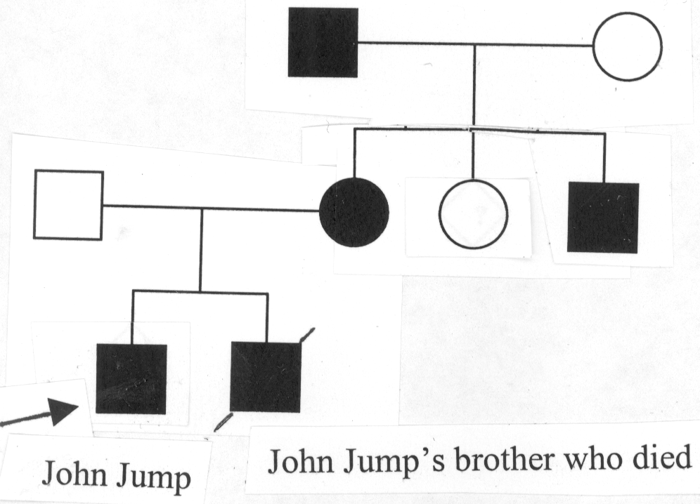

52. Which of the following changes would you most likely observe if you compared the DNA of a normal individual to that of John Jump, at residue 403 of the beta-myosin heavy chain?

Normal John Jump
A. CGC CTC
B. CGG CGT
C. ATG ATT
D. TAG TAT
E. AGA ATA

53. What is the type of physical change that has occurred between the normal and mutant genes?

A. Insertion
B. Mismatch
C. Transition
D. Transversion
E. Deletion

54. What is the type of informational change that has occurred between the normal and mutant genes?

A. Frameshift
B. Missense
C. Nonsense
D. Silent
E. Checkpoint

55. In which of the following parts of the beta-myosin heavy chain gene did this mutation most likely take place?

A. Exon 13
B. Intron 5
C. Polyadenylation signal
D. Transcriptional initiation site
E. Enhancer

56. On the basis of the biochemical and genetic characterization of the R403L mutation and analysis of the pedigree, which of the following represents the BEST description of the class of mutation and the type of inheritance pattern?

Class of mutation Inheritance pattern

A. Loss of function Dominant inheritance
B. Gain of function Recessive inheritance
C. Loss of function Recessive inheritance
D. Gain of function Dominant inheritance

57. If John Jump's disorder has an allele frequency of 1/1000, the frequency of affected individuals assuming Hardy-Weinberg equilibrium is closest to:

A. 1/1000
B. 1/250,000
C. 1/1 million
D. 1
E. 1/500

58. Although Anna Jump also carried the R403L mutation, why did the parents of John Jump initially refuse to cooperate in any study of the cardiac status of other family members?

A. Hers was a new mutation.
B. The inherited trait showed variable expressivity with delayed onset.
C. The mutation showed locus heterogeneity.
D. Their lawyer told them that they could sue the team physician and university for money.

59. This R403L mutation of the beta-myosin heavy chain has been previously reported in the medical literature and the family members of John Jump could easily have been screened if they had cooperated. What would be the best type of probe for screening individuals for this mutation?

A. A probe for variable number of tandem repeat polymorphisms (VNTRs).
B. A probe for short tandem repeat polymorphisms (STRs).
C. A probe for a restriction fragment length polymorphism (RFLP) site.
D. An allele-specific oligonucleotide (ASO) probe.
E. A fluorescent in situ hybridization (FISH) chromosome paint.

60. During DNA replication, the addition of each successive nucleotide occurs in:

A. the 5' to 3' direction on both leading and lagging strands.
B. the 5' to 3' direction on leading strand and 3' to 5' direction on lagging strand.
C. the 3' to 5' direction on leading strand and 5' to 3' direction on lagging strand.
D. either 3' to 5' or 5' to 3' depending on which side of the origin of replication.
E. the 3' to 5' direction on both leading and lagging strands.

END OF EXAMINATION - Tear off this sheet and save to check your answers.

- You may write in your answer to each question on this sheet. DO NOT make any other marks on this sheet. If there are any extraneous marks on this page it will be confiscated.
- Only the answer on the scantron is the official answer. WE CANNOT USE THE ANSWERS ON THIS TEAR OFF SHEET TO DETERMINE YOUR GRADE.

Please remember to:

- Write in the letter of your form in the area titled “Period” on the exam scantron.
- Return your examination in the envelope provided to a proctor before leaving the exam room.

FORM: A

1. _____
2. _____
3. _____
4. _____
5. _____
6. _____
7. _____
8. _____
9. _____
10. _____
11. _____
12. _____
13. _____
14. _____
15. _____
16. _____
17. _____
18. _____
19. _____
20. _____
21. _____
22. _____
23. _____
24. _____
25. _____
26. _____
27. _____
28. _____
29. _____
30. _____

31. _____
32. _____
33. _____
34. _____
35. _____
36. _____
37. _____
38. _____
39. _____
40. _____
41. _____
42. _____
43. _____
44. _____
45. _____
46. _____
47. _____
48. _____
49. _____
50. _____
51. _____
52. _____
53. _____
54. _____
55. _____
56. _____
57. _____
58. _____
59. _____
60. _____

